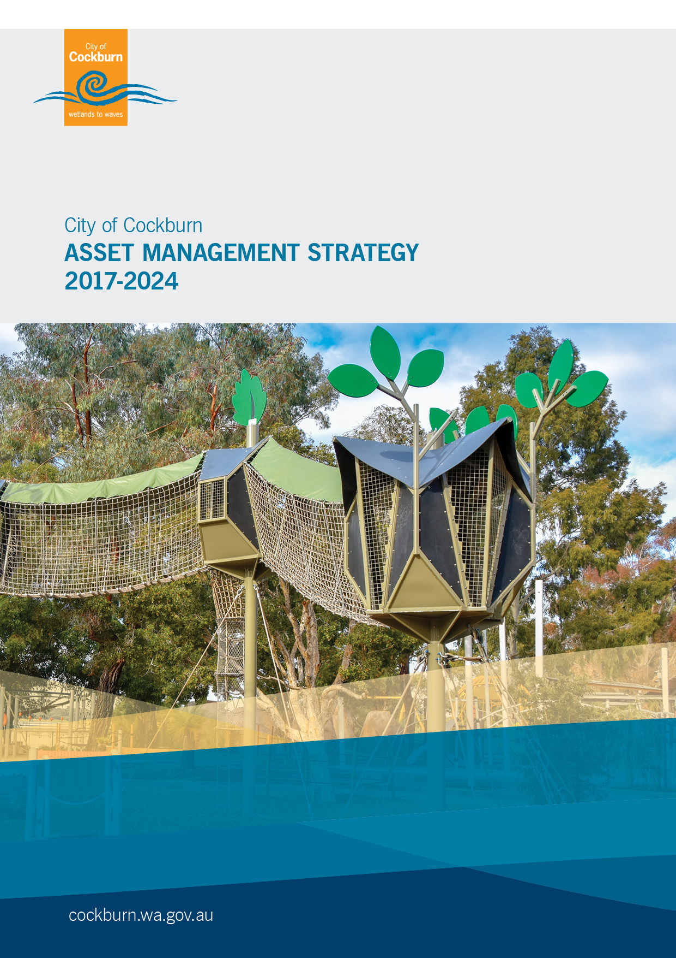

Asset Management Strategy

2017/18 – 2023/24

Table of Content

Executive Summary 3

1 Introduction 5

2 Asset Management Framework 6

3 The City’s Assets 10

4 Review of Achievements to Date 13

5 Vision, Values, Mission 18

6 Links to the Strategic Community Plan 2016 – 2026 and Corporate Planning Framework. 28

7 Objectives / Plan & Resources 30

8 Summary of Community Consultation 36

9 Resourcing the Plan 37

10 Measuring Achievement / Performance Measures 41

11 Reporting format 44

12 Reference and Demographic Information 44

13 Definitions 4345

# Executive Summary

This Strategy outlines the City’s planned implementation and integration of best practice Asset Management planning, systems and processes into Council’s operations. The Strategy is linked to the City’s Asset Management Policy and Asset Management Plans and is a key element of the City’s Corporate Planning Framework.

The implementation of the Strategy will be principally managed and delivered by the City’s Asset Management Services team with involvement from other Service Units within the Engineering & Works Directorate and other Directorates’ including the Financial Services and Information Services Business Units.

The Strategy arises from several strategic objectives of the Strategic Community Plan, principally:

**Community, Lifestyle and Security**

Providing safe, attractive, healthy programs and infrastructure for a diverse range of activity and people

**Leading & Listening**

Being accountable to our community and engaging through multiple communication channels

**Major Objectives**

There are four Major Objectives that will enable the City to continue to improve its implementation of best practice strategic and operational asset management throughout the life of this strategy:

10.1 Asset Management Plan Development & Adoption

10.2 Completion of Infrastructure Asset Condition Surveys

10.3 Completion of an Asset Management Continuous Improvement and Benchmarking Audit

10.4 Further Implementation & Development of the Technology One Asset Management Information System (AMIS)

These objectives are further explored in Sections 9 & 10.

**Resources**

The estimated capital funding proposed for the life of the Strategy is detailed below:

|  |  |  |
| --- | --- | --- |
| **Item** | **Project Program** | **Estimated Budget** |
| 1 | Mobility Field Based Equipment Provision & Replacement | $251,600 |
| 2 | Further Implementation & Development of the Technology One Asset Management Information Systems (AMIS) | $190,000 |
| 3 | Infrastructure Asset Condition Surveys | $480,000 |
| 4 | Asset Management Continuous Improvement and Benchmarking Audit | $20,000 |
| **Total budget Required** | | $941,600 |

**Systems or Communications/Marketing Implications**

The City’s Asset Management Information System (AMIS) is the Technology One Enterprise Asset Management system which has integration to Financials, Property and GIS. The system consists of Registers of the City’s various infrastructure assets and work systems to record and manage asset maintenance activities and capital project management. Additionally the system provides extensive reporting capability with work scheduling and mobile update functionality.

Whilst the Asset Management Strategy did not engage in community consultation directly the City’s Asset Management Planning Framework utilises internal and external Customer Satisfaction surveys to assist to guide the setting of service levels that are key to the management and maintenance of the City’s assets. The application and consultation of the Strategy is effectively internal to the City’s corporate and operational areas of business with minimal external stakeholder and public interface.

# Introduction

This Strategy outlines the City’s planned implementation and integration of best practice Asset Management planning, systems and processes into Council’s operations. The Strategy is linked to the Asset Management Policy and Asset Management Plans and is a key element of the City’s Corporate Planning Framework.

Whilst Asset Management Strategies would normally cover a five year period, this Strategy is framed to cover a further two years from 2017 - 2018 to 2023 - 2024. This is proposed on account of the good progress achieved under the previous Asset Management Strategy and to provide alignment with the City’s Corporate Planning Framework and the development cycle of the City’s Asset Management Plans.

This is further explored in Section 6 - Links to the Strategic Community Plan 2016 –2026 and Corporate Planning Framework.

The Strategy arises from the following objectives of the Strategic Community Plan, principally:

**Community, Lifestyle and Security**

Providing safe, attractive, healthy programs and infrastructure for a diverse range of activity and people

2. Provide for community facilities and infrastructure in a planned and sustainable Manner

4. Create and maintain recreational, social and sports facilities and regional open space

**Leading & Listening**

Being accountable to our community and engaging through multiple communication channels

1. Deliver sustainable governance through transparent and robust policy and processes
2. Ensure sound long term financial management and deliver value for money
3. Provide for community and civic infrastructure in a planned and sustainable manner, including administration, operations and waste management

The City’s Asset Management Policy, Strategy, Plans and objectives are aligned to the International Infrastructure Maintenance Manual (IIMM) ensuring the direction and delivery of the City’s Asset Management Strategies are aligned to best practice and Australian industry standards.

# Asset Management Framework

The City’s Asset Management Framework has been aligned to the Western Australian Department of Local Government and Communities Asset Management Framework since the Framework became a legislative requirement in 2012.

The City has established and embedded all asset management related elements from the Framework into the City’s Corporate Planning Framework.

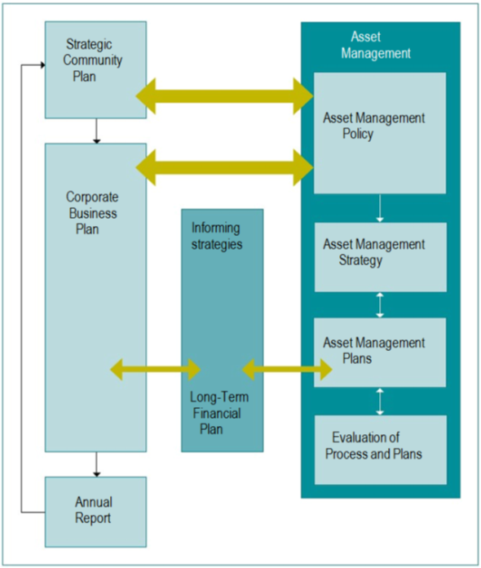

2.1 Dept. of Local Government & Communities - Sustainability Ratio Performance

There are three key performance indicators for financial sustainability as recommended in the Department of Local Government & Communities (LG) Asset Management National Framework and Guidelines.

The aim of the Framework is to enhance the sustainable management of local government assets by encouraging ‘whole of life’ and ‘whole of organisation’ approaches and the effective identification and management of risks associated with the use of the assets.

2.1.1 Asset Consumption Ratio (ACR)

This ratio shows the written down current value of the City’s depreciable assets relative to their ‘as new’ value in up to date prices.

It is calculated by dividing the written down value, also known as the Fair Value, by the current replacement cost from the City’s operational and financial asset registers.

|  |  |  |  |  |  |
| --- | --- | --- | --- | --- | --- |
| **Asset Group** | **Asset Consumption Ratio (ACR) (%)** | | | | |
| **2012 - 2013** | **2013 - 2014** | **2014 -2015** | **2015 -2016** | **2016 -2017** |
| Roads | 69.87 | 69.56 | 71.53 | 69.46 | 60.91 |
| Buildings | 56.54 | 53.52 | 64.40 | 63.00 | 74.22 |
| Parks & Environment | 61.80 | 66.05 | 63.57 | 62.99 | 64.31 |
| Marine & Coastal | NC | NC | NC | NC | 98.2 |
| Fleet & Plant | 63.39 | 57.81 | 55.99 | 55.00 | 63.12 |
| Drainage* | 80.91 | 79.92 | 80.52 | 80.31 | 80.61 |
| ICT | 12.29 | 9.12 | 36.57 | 61 | 45 |
| Footpaths | 71.09 | 72.66 | 73.28 | 73.52 | 62.81 |

**(NC) Not Calculated** – As the Marina was donated to the City in July 2016.  
  
The target ratio should be between 50% and 75%. A ratio of less than 50% indicates a rapid deterioration of the asset base, whilst a ratio greater than 75% may indicate either an over investment in the asset base, assets with a longer useful life or an organisation that is still experiencing growth.

* The Drainage ACR is greater than 75% due to the majority of their assets having high useful life’s (100 years) and as a result of the City receiving donated assets with a Current Replacement Cost of $24.6m since 2012.

2.1.2 Asset Sustainability Ratio (ASR)

This ratio indicates whether assets are being replaced or renewed at the same rate that the overall asset stock is wearing out.

It is calculated by dividing the annual capital expenditure spent (funding) on renewals by the annual depreciation expense

The forecast ratios have been calculated on an accumulative basis.

|  |  |  |  |  |  |  |
| --- | --- | --- | --- | --- | --- | --- |
| **Asset Group** | **Forecast Asset Sustainability Ratio (accumulative)** | | | | | |
| **2018- 2019** | **2019- 2020** | **2020- 2021** | **2021- 2022** | **2022- 2023** | **2023- 2024** |
| Roads | 2% | 5% | 30% | 57% | 39% | 25% |
| Buildings | 10% | 27% | 23% | 15% | 27% | 32% |
| Parks & Environment | 33% | 34% | 38% | 34% | 39% | 38% |
| Fleet & Plant | 75% | 59% | 113% | 117% | 108% | 73% |
| Drainage | 27% | 30% | 33% | 33% | 35% | 36% |
| Footpaths | 28% | 37% | 132% | 188% | 40% | 3% |

The Asset Sustainability Ratio is calculated based on a projected yearly depreciation increase of 1.75%. from the Long Term Financial Plan (LTFP).

The target ratio should be between 90% - 110%.

The ICT and Marine & Coastal Asset Group has been omitted as the ratio will be calculated during the development of the 2017 - 2018 to 2019 - 2020 AMP.

2.1.3 Asset Renewal Funding Ratio (ARFR)

This is an indicator as to the ability of the City to fund the projected asset renewals in the future and therefore continue to provide existing levels of service, without additional operating income or reductions in operating expenses, or an increase in net financial liabilities above that currently projected.

It is calculated by dividing the projected capital expenditure on renewals (condition-based) over the 10 years by the LTFP budget allocation on renewals over the same period.

|  |  |  |  |  |  |  |
| --- | --- | --- | --- | --- | --- | --- |
| **Asset Group** | **Asset Renewal Funding Ratio** | | | | | |
| **2018-2019** | **2019-2020** | **2020-2021** | **2021-2022** | **2022-2023** | **2023-2024** |
| Roads | 75% | 80% | 85% | 90% | 95% | 100% |
| Buildings | 75% | 80% | 85% | 90% | 95% | 100% |
| Parks & Environment | 75% | 80% | 85% | 90% | 95% | 100% |
| Fleet & Plant | 75% | 80% | 85% | 90% | 95% | 100% |
| Drainage | 75% | 80% | 85% | 90% | 95% | 100% |
| Footpaths | 75% | 80% | 85% | 90% | 95% | 100% |

The Asset Renewal Funding Ratio is calculated based on LTFP funding and a graduated increase of 75% in 2018 – 2019 to 100% in 2023 - 2024 .

The ICT and Marine & Coastal Asset Group has been omitted as the ratio will be calculated during the development of the 2017 - 2018 to 2019 - 2020 AMP.

The target ratio should be between 95% and 105%. A ratio of between 50% and 75% indicates that adequate provision is not being made for the future renewal of assets.

# The City’s Assets

3.1 State of the Assets

The financial status of Council owned assets as at 30 June 2017 is shown in Table 1.

**Asset Summary**

|  |  |  |  |
| --- | --- | --- | --- |
| Asset Group | Replacement Cost ($000) | Fair Value ($000) | Annual Depreciation ($000) |
| Roads | $577,410,636 | $351,679,673 | $13,234,068 |
| Buildings | $288,548,238 | $215,145,419 | ~$5,360,475 |
| Parks & Environment | $62,627,361 | $40,278,320 | $3,376,249 |
| Marine & Coastal | $52,608,256 | $51,343,715 | ~$946,000 |
| Fleet & Plant | $23,147,536 | $14,341,903 | ~$2,872,152 |
| Drainage | $253,243,592 | $204,129,169 | $2,532,436 |
| ICT | $4,472,378 | $3,595,365 | $1,165,817 |
| Footpaths | $65,378,280 | $41,062,238 | $1,369,284 |
| **Total** | $1,327,436,277 | $921,575,802 | $20,437,592 |

Table 1

* Includes Cockburn ARC  
  
The lower fair value for Buildings and Marine & Coastal assets is on account of the recent handover of the Port Coogee Marina Complex and the recent construction and handover of Cockburn ARC.

3.2 Condition summary graph

The condition summary of Council owned assets as at 30 June 2017 is shown in Table 2

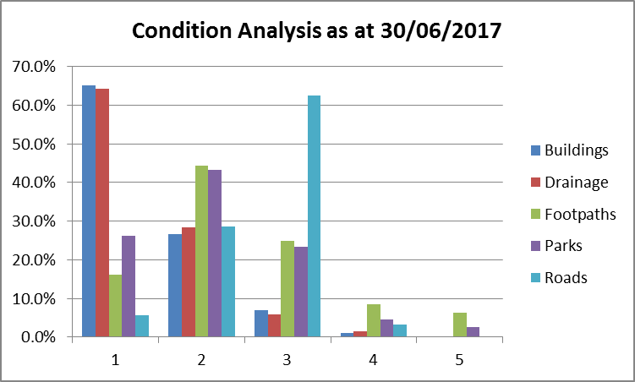 Table 2

The condition profile for the City’s Assets are measured using a 1-5 scoring system outlined below.

|  |  |  |
| --- | --- | --- |
| **Rating** | **Condition** | **Description** |
| **1** | Excellent | A new asset or an asset in overall excellent condition with only a slight condition decline |
| **2** | Good | An asset in an overall good condition but with minor signs of deterioration evident, serviceability may be slightly impaired. Minor maintenance is required |
| **3** | Moderate | An asset with obvious signs of deterioration. Significant maintenance is required |
| **4** | Poor | An asset in a poor condition. Condition deterioration is severe and serviceability is becoming limited. Significant renewal or upgrade is required |
| **5** | Very poor | An asset that has failed and is no longer serviceable. There would be a risk in leaving the asset in service. Replacement is required |

**Please note:** Condition ratings for Marine, Fleet & Plant and ICT Infrastructure assets are to be determined during development of the 2017 - 2018 to 2019 - 2020 Asset Management Plans.

3.3 Growth – Donated Assets Summary 2012 - 2017

The City continues to experience growth in its assets across all infrastructure areas through its own construction works and from external sources arising from developer handover of new subdivisions and other donated assets.

The total replacement cost for donated assets between 2012 and 2017 has been valued at $119,951,616. A detailed group based breakdown of the donated assets is provided in the following graph.  
   
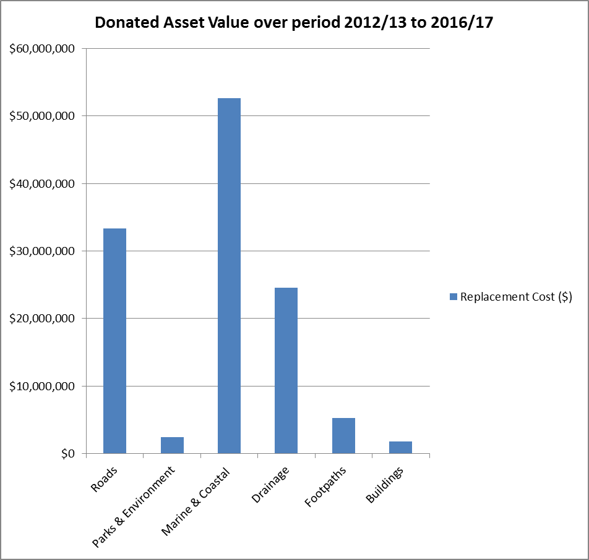

**Please note:** No donated Assets have been received for Fleet & Plant and ICT Infrastructure for the period of 2012/13 to 2016/17.

# Review of Achievements to Date

The previous Asset Management Strategy and Implementation Action Plan outlined four high level objectives.

The following table provides a review and current status of these objectives and the specific deliverables that were targeted for implementation.

**Key to status**

Not Started

In Progress

Established as an Operational Practices/Process

|  |  |  |
| --- | --- | --- |
| **Objective 1** Development of Asset Management Plans for all major asset classes | | |
| **Deliverable** | **Status** | **Comments** |
| AMP’s developed for all major asset classes |  | In 2013 the City adopted core level AMP’s for the following asset classes:   1. Road Infrastructure 2. Drainage Infrastructure 3. Buildings 4. Footpath Infrastructure 5. Parks & Environment   For the period of 2014 - 2017 the previous 5 AMP’s were enhanced to intermediate level and were joined by a sixth AMP (Fleet & Plant). These AMP’s were the first AMP’s which established linkages to the City’s LTFP in the form 10 year projected renewal programs and incorporating LTFP funding strategies back into the plans (completing the circle).  New and revised AMP’s are currently in development for the period of 2017- 2018 to 2019 - 2020. The existing six plans will be updated and will be joined by two new plans for Marine & Coastal Infrastructure and ICT Infrastructure. |

|  |  |  |
| --- | --- | --- |
| **Objective 2** Implementation of an Asset Management Information System (AMIS) establishing one centralised database with capability and functionality to capture the following: | | |
| **Deliverables** | **Status** | **Comments** |
| Asset Condition |  | All assets recorded within the City’s AMIS are rated on a scoring system of 1 -5. Asset Condition ratings are established via external or internal inspection audits except drainage assets which have been calculated based on useful life and the construction year. |
| Level of Service measures – current and desirable; |  | The City’s Community and Technical Levels of Services have been established in each of the City’s AMP’s and incorporated into the City’s AMIS. The City’s AMIS is capable of measuring performance for planned and reactive maintenance against these services levels. This has been established for Parks with further development required for other asset groups. |
| Integration with Corporate Information Systems i.e., Financial Management and GIS systems |  | The City’s Operational Asset register is integrated with the GIS Asset Register on a one to one basis. The GIS environment is the master data set and is updated by approved and trained staff. The Technology One system is reconciled and synced with the GIS register monthly as part of the Assets Services Team’s data standards and quality assurance procedures.  Alignment with the City’s Financial asset registers is carried out yearly upon the completion of the following infrastructure asset revaluations.   1. Roads & Paths Infrastructure 2. Parks Infrastructure 3. Drainage Infrastructure 4. Signs, Lighting and Fencing Infrastructure   Buildings, Marina and Fleet & Plant are revalued by the City’s Financial Services Business Unit and are not derived from the Operational asset registers managed by Asset Services. |
| **Deliverables** | **Status** | **Comments** |
| Age and Anticipated Remaining Useful Life; |  | All assets have been assigned an appropriate useful life to a group or hierarchy level based on industry, internal knowledge and historical data which is utilised for long term planning and integration into the City’s Long Term Financial Plan. |
| Asset Revaluations for cost estimating purposes and long term planning. |  | Since 2012 Asset Services have carried out yearly fair value based asset revaluations for Road, Footpath, Drainage and Park infrastructure. The revaluation reports have been developed within the City’s AMIS and are aligned to the City’s Financial asset registers.  Financial Services continue to carry out revaluations every 3 years for the Marina and Buildings via external audit and for plant & machinery infrastructure internally. |

|  |  |  |  |  |
| --- | --- | --- | --- | --- |
| **Objective 3** Development of renewal programs (10 year) for inclusion in the Long Term Financial Plan (LTFP). | | | | |
| **Deliverable** | **Status** | | **Comments** | |
| Forward works programs for all major asset classes. |  | | Created as part of the City’s Asset Management Planning Process and the development cycle for the City’s AMP’s. The renewal programs and AMP’s act as informing strategies to support the development of the LTFP.  Renewal programs have been integrated into the previous two LTFP’s. The City’s next AMP’s will again inform the next LTFP (2018 - 2019 to 2027 - 2028) which will be adopted in the 2nd Quarter of 2018.  The renewal programs provide 10 year projections based on asset condition, useful life and various asset attribute data to determine replacement costs depending on the projected year for replacement/rehabilitation. | |
| **Objective 4** Data Management strategy Inc. formalised processes developed for the following: | | | | |
| **Deliverables** | | **Status** | | **Comments** |
| Periodic scheduled condition assessments | |  | | The City has established a regular funding model to carry out asset condition audits typically on rolling 4 year cycles for each of the major asset classes.  Whilst the Assets Team and various internal Operational Teams have the capability to carry out inspections and condition assessments outsourcing these periodically scheduled surveys provides the most consistent, manageable and resource efficient approach. |
| Greater responsibility and ownership for the management of data by Managers & Asset Custodians. | |  | | The Asset Team is responsible for the governance and quality assurance of the asset data received for donated assets or generated via the City’s capital work programs.  The responsibility for updating and capturing the data has been decentralised with the improvement of the City’s AMIS and the introduction of Data Entry Forms in GIS which provide designated users access to create, maintain and dispose of assets in a controlled and auditable environment.  The creation of the following process maps have established clear roles and responsibilities across the organisation to ensure that data management is a fundamental element of day to day business:   1. New Assets Capture: Final Design or As Constructed (Major Capital Projects only) 2. New Subdivisions (Donated Assets) DSPEC & RSPEC. 3. New/Renewal of Assets (Minor Capital Projects i.e. resurfacing, playgrounds, building infrastructure. 4. New Subdivisions (Donated Assets) OSPEC. 5. Disposal of Assets |
| **Deliverables** | | **Status** | | **Comments** |
| External and internal handover processes for sub divisions and capital works programs | |  | | Formal ASPEC handover processes for new subdivisions for Road and Drainage Infrastructure (RSPEC & DSPEC) have been established, ensuring that asset as- constructed data from external surveyors and developers is consistent with established industry standards and the City’s asset register configuration.  OSPEC (Open spaces) has not yet been adopted as a subdivisional development handover requirement however the data structure is established across the City’s AMIS (Technology One), with all internal data capture aligned to the specification.  A data specification for the handover of Building assets is not aligned to ASPEC but is based on the City’s internal data requirements. The data structure has been embedded into all Engineering & Works building service and project related contracts and tenders where a handover of asset data is required. |
| Adoption, alignment and integration of ASPEC data specification into the City’s AMIS and subdivision design specification. | |  | | The City has established the ASPEC data specification across the City’s AMIS and GIS operational registers.  Additionally the specification is currently being reviewed to determine suitability for the capture of asset related data for internal capital work projects. |

# Vision, Values, Mission

5.1 Vision

*“To ensure that Council’s infrastructure and other assets are provided and maintained in a manner that achieves the community and technical service levels that we aspire to and our Stakeholders require of us, in a cost effective manner through an optimal balance of creation, preservation, enhancement and disposal.”*

5.2 Mission

The City’s mission is to make the City of Cockburn the most attractive place to live, work, visit and invest in, within the Perth metropolitan area.

5.3 Values

1. Customer Service  
    We are committed to giving the best possible customer service

Demonstrable Behaviours:

* 1. Understands and abides by the City of Cockburn Customer Service Charter
  2. Promotes a positive image of the City of Cockburn
  3. Communicates effectively

1. Excellence  
   We strive for Excellence

Demonstrable Behaviours:

1. Demonstrates motivation to constantly strive for self-improvement
2. Understands and accepts the concept of continuous improvement
3. Displays self-motivation to stay focused and committed to a task
4. Safety  
   Safety is an Integral part of all that we do

Demonstrable Behaviours:

1. Works within the City’s OSH policies and procedures
2. Identifies and reports safety issues
3. Contributes to safety discussions
4. Accountability  
   We are honest. We are accountable for our actions and decisions

Demonstrable Behaviours:

1. Takes responsibility for the consequences of actions and decisions
2. Confronts controversial or difficult issues in an objective manner
3. Identifies and appreciates the value of performing duties according to the intent of company policies and guidelines
4. Demonstrates and communicates a high level of ownership and commitment to achieving results
5. Sustainability  
   We consider the natural, financial and social implication of our decisions

Demonstrable Behaviours:

* 1. Evaluates future implications of current decisions and actions
  2. Avoids ‘waste’ of resources
  3. Understands the needs of customers and the community
  4. Considers the impact of decisions on the environment

## 5.4 Asset Management Governance & Structure

To provide alignment to the Dept. of Local Government and Communities Asset Management Framework the City has established five Service Areas and Programs to manage, support and deliver Asset Management across the Organisation.

The Asset Services S/U promotes and proactively leads an Organisational approach to asset management across the five service areas, by establishing integral links with Financial Services, Information Services inc GIS and Business Systems and Human Resources.

|  |  |
| --- | --- |
| **Service Area** | **Program** |
| 1. **Strategic Asset Management** | 1. Policy & Strategy Development 2. Projected 10 Year Renewal for LTFP development 3. 4 year rolling program development - Asset deterioration modelling. |
| 1. **Operational Asset Management** | 1. Recording and reporting Levels of Service & cost capture 2. Established Processes for capturing As-constructed   asset information inc new, renewal, upgrade & disposal |
| 1. **Asset Information Management Systems (operational & capital)** | 1. Implementation, Development, Integration, Training & Support of the City’s AMIS and associated data and processes. |
| 1. **Asset Inspections and Audits**   **(Internal & External)** | 1. Budget preparation, scoping and management of external audits. 2. Internal programmed inspections based on asset performance and risk. |
| 1. **Asset Management Procedures and Practices** | 1. Asset Management Plan Development 2. Asset Management Benchmarking and Compliance with Legislation (Dept. of LG's Framework) 3. Infrastructure Revaluations for all Asset Groups 4. Data & Process Improvement Initiatives |

The Asset Services Service Unit resides within the Infrastructure Services Business Unit of the Engineering and Works Directorate. The Service Unit has evolved over a number of years reflecting the growing maturity of the City’s asset management practices and procedures and the competencies of the Team members.

The Service Unit has diversified in its approach to asset management by developing efficient, sustainable and more accountable procedures and processes, The focus ensures that continuous improvement of asset management is a core goal of the team and the organisation. Additionally the Team has prioritised the development and enhancement of the City’s AMIS as a core deliverable across the Engineering & Works Directorate, whilst also contributing and supporting Corporate wide improvements initiatives, i.e. Project Portfolio Management (PPM), Request Management and the Australasian LG Performance Excellence Program.

The Service Unit commences this Strategy period with four full time employee (FTE) positions as represented below that collectively have skills and experience in the following areas:

|  |  |
| --- | --- |
| **Internal Skills** | **Asset Services Team Structure** |
| 1. Engineering & Infrastructure   Provision   1. Information & Communication   Technology (ICT) & Systems   1. Project Management. 2. Process Improvement 3. Change Management 4. Financial (Valuations) 5. GIS Technologies/Mapping |  |

Reporting to and supported by the Manager Infrastructure Services the Infrastructure Asset Manager has responsibility for the development and direction of asset management across the organisation, including direct responsibility for the delivery and implementation of each of the major objectives outlined in the Asset Management Strategy and the Improvement Strategies from the City’s Asset Management Plans.

## 

## 5.6 Levels of Service

For each asset group target technical and community levels of service are established and documented in the relevant Asset Management Plans. These service levels include operational targets such as number of times a park will be mowed each year, as well as technical standards that need to be complied with.

Service levels are set with the aim of achieving an acceptable standard that meets community expectations without over servicing and thus incurring unnecessary costs for the City.

Developing mechanisms for determining the accurate cost of delivering services remains a significant undertaking for many Local Governments as it requires structured agreed operational activities and an Asset Management Information System (AMIS) that has the functionality to capture, report and monitor operational activities to form a true and real life baseline of current and historical performance.

## 5.6.1 Current Status

For the Parks & Environment Business Unit, planned maintenance regimes have been capturing service level data for the previous three financial years for Irrigation, Mowing, Landscaping, Tractor Mowing and Asset Maintenance activities within the City’s AMIS based on the following criteria:

1. Performance Measurement: Planned Maintenance frequency established (ranging from 7, 14, 21 and 28 days through to monthly and yearly intervals).
2. Budget & Performance Recording: Estimated Hours vs Actual Hours for each instance of maintenance activity (Labour Hrs.).

The AMIS has been developed to produce reports as detailed on the following page and represents the most advanced form of service level data capture and reporting within the Engineering & Works Directorate.

**Mowing Maintenance Summary   
(Scheduled vs Completed Visits and Estimated vs Actual Hours)**

**Grouped by Parks Class for financial year 2016 - 2017.**

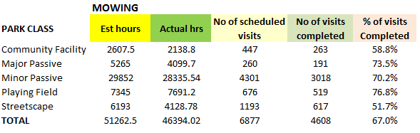

**Landscaping Maintenance Summary   
(Estimated vs Actual Hours)**

**Grouped by Parks Class for 2016 - 2017.**

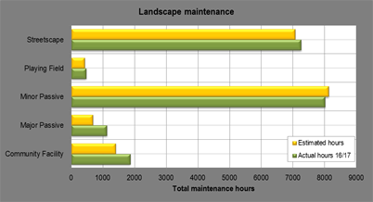

## 5.6.2 Future Developments and Improvements

Within the 2018 -2019 financial year the capability to better capture service frequencies and costs will be extended to the Facilities & Plant and Roads Services S/U’s. Additionally with the future implementation of eContractor the City will be able to monitor and report on the performance of appointed contractors, thus ensuring that awarded contracts can be performance managed to the same degree as our internal operational maintenance teams and personnel.

For the Parks & Environment Business Unit there will be a comprehensive review of the historical service data prior to the commencement of the 2018 – 2019 that will assist to establish new service levels.

The recording and reporting of service levels within the City’s AMIS represents a significant millstone for operational asset management activities. Furthermore, over the next two to three years future forecasting of operational and maintenance budgets from actual asset based service levels and historical operational performance data will improve upon current forecasting techniques and methods.

## 5.7 Risk Management

In 2015 the City implemented a Risk Management & Safety System (RMSS) in which all operational and strategic risks are captured, rated and receives ongoing monitoring based on their level of risk.

Additionally, in 2017 the Risk Management Framework was adopted with the aim of supporting an integrated and effective organisational wide approach to risk management.

The implementation of the Framework will:

1. Ensure a consistent approach to the risk management process across Council;
2. Establish a structured process for undertaking the risk management process to identify, assess and control/treat risks;
3. Encourage the integration of risk management into the strategic and operational process across all Business Units of the Council

The Risks associated with Asset Management are categorised as Strategic and Operational as detailed below.

**Strategic Risks**

1. Public Safety (Risk Rating – Moderate)

Failure to provide an environment that promotes health, safety and wellbeing of community

1. Strong Financial Position (Risk Rating – Moderate)

Inability to sustain City's strong financial position

1. Coastal Hazards (Risk Rating – Low)

Fail to consider and adequately manage coastal planning and related coastal erosion

**Operational Risks**

1. Asset Management Legislation (Revaluations) (Risk Rating – Low)

Failure to comply with relevant asset management regulations (Accounting Standards)

1. Asset Management Plans (Risk Rating – Low)

Failure of Council and Services Areas to update and utilise asset management plans

1. Asset Management Plans & LTFP (Risk Rating – Low)

Lack of reliable, accurate/or current data for asset management

Each of the risks are reviewed with current and proposed control measures being assessed yearly to ensure industry standards and potential advancements are considered and incorporated as required.

## 5.8 Asset Deterioration, modeling and Optimisation

During the life of this Strategy the City intends to invest in the Technology One Strategic Asset Management (SAM) Prediction Modelling & Optimisation solution. The implementation of the software will enable the City to utilise the existing asset data to project with greater certainty and accuracy future renewal periods/remaining life and future expenditure for capital works programs (refurbishment, upgrade, renewal and disposal) and the LTFP.

With the introduction of the modelling and optimisation technology all ASPEC assets will be enhanced from recording the standard condition rating 1-5 scoring system to include function, capacity, utilisation, operating and maintenance costs and finally risk which will be rated on a 1-10 scoring system in line with ISO 31000.

The purpose of this additional criteria will be to formalise appropriate intervention strategies and to determine with greater accuracy and confidence future intervention points for Renewal, Upgrade, New and Disposal of assets during their lifecycle.

Additionally the proposed improvements to the City’s asset data sets will provide the specification for all future externally sought asset data condition surveys, ensuring that the City continues to further strengthen our processes and standards for data capture and collection.

This initiative is further explored in section 7 Objectives / Plan & Resources point 4.4 Strategic Asset Management (SAM)

## 5.9 Data & Systems to support Asset Management

The City has invested consistently on all aspects of asset management including implementation of systems, training and data management improvement initiatives.

This investment has enabled the Engineering & Works Directorate to modernise and embed continuous improvement and best practice across its operational activities with the aim of establishing sustainable and efficient procedures to improve the City’s operational and strategic asset management objectives.

For approximately 10 years the City has been a consortium member of ASPEC Digital Data Specification which is an industry standard specification for the supply of digital data relating to ‘As Constructed’ infrastructure asset information.

The City has adopted the international specification for Road, Drainage, and Openspace hard infrastructure and has embedded these specifications across our GIS and Technology One Asset Registers. With the alignment of the specification and our asset registers, the handover of digital donated assets from Surveyors into the City’s AMIS has been simplified and streamlined.

## 5.10 Asset Management Information Systems (AMIS)

Since 2008 the City has invested approximately $400,000 in the ongoing implementation and development of the Technology One Asset Management Information System (AMIS) and associated systems.

The City’s AMIS is recognised as a market leader and as an advanced asset management system across the Western Australian Local Government community. Additionally both Technology One LTD & Gissa International PTY LTD promotes the City and its AMIS as a reference site for other clients due to the level of functionality established and the integration and alignment with the ASPEC Data specification.

**Notable Achievements:**

1. Implementation of Work Management Mobility (currently 49 Tablets deployed).
2. Implementation of GIS Integration with Intramaps.
3. Utilsing work orders for electronic Timesheets and cost capture for operational activities within the Engineering & Works Directorate.
4. Asset Revaluation and Asset Management Plan reporting.

The City has utilised functionality from the Technology One AMIS and Intramaps solutions to establish and ensure ongoing management, responsibility and quality assurance of asset data. This is supported further by the creation and acceptance of documented processes with defined roles, responsibilities and ownership that is auditable and accountable.

The screen shot below represents the workflow of the City’s Operational Asset Register including the various inputs, environments the data is captured, the integration points and quality assurance elements established to manage the agreed organisational outputs.

**Operational Asset Management Register Configuration and Workflow developed by the Asset Services Service Unit.**

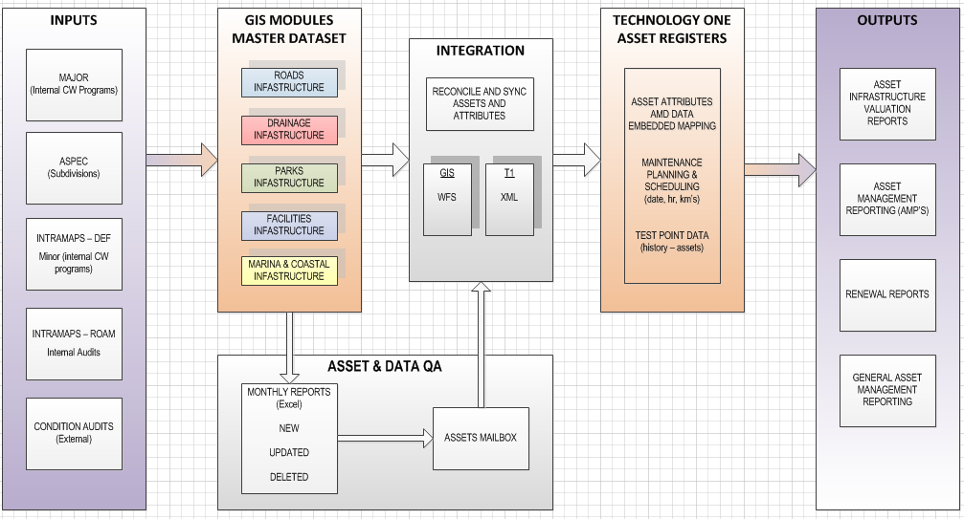

The following asset registers and associated work systems have been developed and deployed:

* Road, Footpath Road Item Infrastructure
* Plant & Machinery
* Parks – Soft & Hard Infrastructure
* Drainage (Asset Register only)
* Buildings
* Marine & Coastal Infrastructure (Asset Register only)

**Operational Asset Management Work Systems Configuration and Workflow developed by the Asset Services Service Unit.**

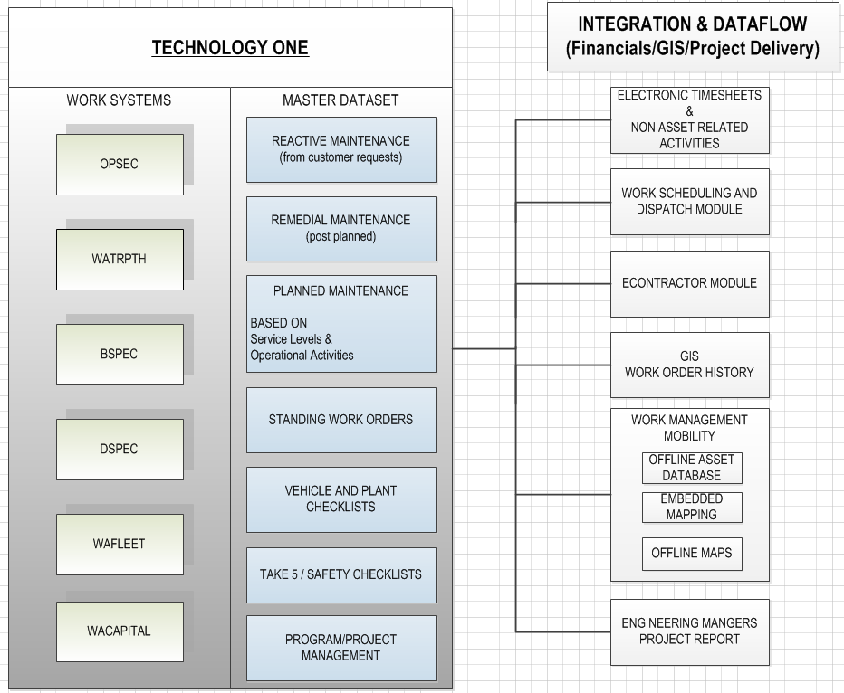

Additional Projects and AMIS functionality established:

* Capital Projects Management
* GIS Integration – Reconciliation & Synchronisation modules
* Work Management Mobility inc offline Database & Maps for 49 Crews/Tablets
* Electronic Asset Data Collection via Intramaps Roam
* Work Scheduling & Dispatch – Plant, Parks & Roads - Trial
* Electronic Timesheets for Plant and Parks via Work Orders
* Asset Revaluation reports for Auditors (ASPEC)
* Asset Management Plan reporting

Development of the City’s AMIS will continue throughout the life of this Strategy and will focus on the continuous improvement, development and refinement of our systems and associated procedures and practices.

Objectives and Plans relating to the ongoing development of the City’s AMIS by Asset Services is further explored in section 7 Objective / Plans and Resources.

# 6 Links to the Strategic Community Plan 2016 – 2026 and Corporate Planning Framework.

The City’s Asset Management Planning Framework, led by the Asset Management Policy outlines the City’s responsibilities for managing Council infrastructure assets establishing an organisational approach to asset management that supports and informs the City’s Corporate Planning Framework.

## 6.1 Asset Management Strategy

This Asset Management Strategy in conjunction with the Asset Management Policy provides the City with the high level long-term approach to Asset Management including AM action plans and objectives for managing the City’s assets.

Whilst the Asset Management Strategy is normally a five year document, this revision will have a 7 year life and will cover the development and delivery of the next two Asset Management Plans (2017 - 2018 to 2019 - 2020 and 2020 - 2021 to 2023 - 2024).

From 2024 - 2025 onwards the Strategy will cover four year cycles providing financial and strategic alignment to the City’s Corporate Planning Framework. This will ensure that Asset Management Plans and its overarching Asset Management Strategy are developed in parallel, cover the same period and future funding needs are incorporated directly into the LTFP (Asset Renewals from AMP’s and Objective/ Plans from the AMS).

The following diagram provides a visual representation of the periods and timelines of the City’s Corporate Planning Framework. The Asset Management Plans and Strategy act as informing strategies to the Corporate Framework demonstrating the City’s increasing maturity whilst recognising the importance of Asset Management related activities on the long term financial sustainability of the organisation.

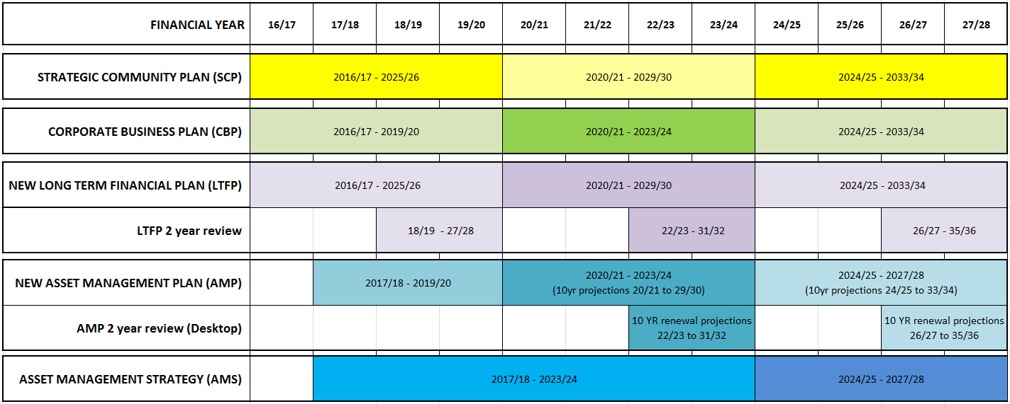

## 6.2 Asset Management Plans

The City created its 1st AMP’s in 2013 when five plans were adopted for the Asset Groups shown in the table below. The AMP’s were developed to a basic level as per the International Infrastructure Maintenance Manual (IIMM) and reflected the City’s maturity at that time.

**Asset Management Plan Development History**

|  |  |  |  |
| --- | --- | --- | --- |
| **Asset Management Plan** | **2013** | **2014 – 17** | **2017/18 – 19/20** |
| Drainage Infrastructure |  |  |  |
| Footpath Infrastructure |  |  |  |
| Road Infrastructure |  |  |  |
| Buildings |  |  |  |
| Parks & Environment |  |  |  |
| Plant & Fleet |  |  |  |
| Marine & Coastal Infrastructure |  |  |  |
| ICT Infrastructure |  |  |  |

To establish closer integration and alignment with the City’s LTFP each of the above AMP’s and in addition Plant & Fleet were revised and readopted for the period of 2014 -2017. Following an internal review the AMP’s were assessed in line with the IIMM as intermediate level plans reflecting the City’s continued improvement and growing maturity.

The Assets Team is currently reviewing the six current AMP’s and working closely with the Business Unit’s to establish a further two new AMP’s for Marine & Coastal Infrastructure and ICT Infrastructure.

The development of the 2017 - 2018 to 2019 0 2020 (3 years) AMP’s will support the 2 yearly review of the current LTFP (2016 - 2017 to 2025 - 2026), which will commence in November 2017 with planned completion in the 1st Quarter of 2018.

The eight AMP’s will be adopted early 2018 and will act as bridging plans until alignment with the City’s four yearly Corporate Planning Framework is achieved.

# 7 Objectives / Plan & Resources

## 7.1 Asset Management Plan Development

As the City’s AM practices have matured and become established into the Corporate Planning Framework from 2021 - 2022 the City’s Asset Management Planning process and AMP’s will be developed for 4 year periods with 2 year reviews similar to the approach established for the development of the City’s LTFP’s.

Outlined below is a detailed view of the proposed future development cycle of the City’s AMP’s during the life of the Strategy further reinforcing the plans as key informing strategies for the development and review of the City’s LTFP’s, derived from the latest asset valuations, growth, operating and sustainability ratios and 10 year renewals (funding projections).

The City’s eight AMP’s for 2017 - 2018 to 2019 - 2020 (listed under section 6.2) will be redeveloped and accompanied by a 9th AMP specifically developed for Cockburn ARC from 2020 -2021 onwards.

**Development schedule of Asset Management Plans during the life of the Asset Management Strategy.**

|  |  |  |  |  |
| --- | --- | --- | --- | --- |
| **Activity** | | **Renewal Projections** | **Development Period** | |
| **AMP 17/18 to 19/20** | | 2018 - 2019 to 2027 - 2028 | Jul-17 | Feb-18 |
|  |  |  |  |  |
| **AMP 20/21 to 23/24** | | 2020 -2021 to 2029 - 2030 | Jul-19 | Feb-20 |
| **2 Year LTFP Review**  **(Revaluations & Renewals Projections)** | | 2022 -2023 to 2031 - 2032 | Jul-21 | Sep-21 |

## 7.2 Completion of Infrastructure Asset Condition Surveys

The City recognises the importance and its responsibility to manage its assets to achieve optimum life whilst maintaining levels of service. The need for the City to schedule 4 yearly surveys for major asset groups will ensure that the City has a greater understanding of what assets we have and how they are performing.

The scheduling of surveys will fall due during the financial year prior to the development of the City’s Asset Management Plans ensuring that AMP’s, Capital Work Programs and renewal projections for the LTFP are formed from the very latest condition based asset data.

Each audit will be internally developed and managed by Asset Services two Technical Officers in conjunction with key personnel from each of the various Engineering Directorate Business Units to ensure the following:

**Audit Requirements and Deliverables:**

1. Alignment with ASPEC Data Standards (R,O,B & M specs).
2. All assets condition rated on a 1-5 scale (See page 10 for further details)
3. Identification of Asset Defects to develop work programs and manage risk.
4. Data provided spatially to provide easy transition into the City’s AMIS.
5. Asset ratings captured for function, capacity, utilisation to support and development and future projections from the City’s Technology One Strategic Asset Management (SAM) Prediction Modelling & Optimisation solution.

## 7.3 Completion of an Asset Management Continuous Improvement and Benchmarking Audit

The City will engage an outside and independent resource to audit, assess and benchmark its Strategic and Operational asset management practices. The initiative will be designed to take a City wide approach to ensure current status and future requirements are recognised and acted upon.

**Benchmarking Focus areas:**

1. Strategic long term planning (LTFP Integration)
2. Budget & Annual report inc Asset Revaluations
3. Asset management policy
4. Asset management strategy
5. Asset management plans
6. Governances and management
7. Defining levels of service
8. Data and systems
9. Skills and processes

**Expected Benefits:**

1. Further strengthen the City’s Asset Management Planning Framework
2. Benchmark performance and ensure compliance with the International Infrastructure Maintenance Manual (IIMM)
3. Review and Alignment with the requirements of ISO 55000 on the City’s Asset Management Framework.

7.4 Further Implementation and Development of the Technology One Asset Management Information System (AMIS)

## 7.4.1 Electronic Timesheets for Roads and Facilities Operational Activities

Currently the City has established electronic timesheets for Plant Services and Park Services with the mechanics and leading hands responsible for capturing crew and/or combined actual hours electronically via the work order systems developed within the City’s Technology One AMIS.

With the completion of the Facilities Asset Management Systems build and the 2nd and final phase of the Roads Mobility project due to be completed by first quarter of 2018 the intent is to provide similar functionality for all business areas within the Engineering & Works Directorate.

**Expected Functionality and Benefits:**

1. Removal of the daily paper based timesheet.
2. Reduced resources required by Finance and Payroll Services to process operational staff timesheets.
3. Introduce a concept of weekly exception reporting signed off by supervisor and or lead staff.
4. Improved data accuracy as Actual Hours are entered electronically to work orders via tablets.
5. Remove double handling of data by establishing the key personal as the single point of data entry for the completion of work orders.

## 7.4.2 Continued rollout off Mobility, including GIS access in the field and in field asset data access and updating.

The City has invested significantly in the deployment of workforce mobility across the Engineering & Works Directorate with currently 49 tablets in Roads, Parks, Bushland and the Workshop, with Facilities planned for early 2018.

Whilst the early phases of mobility have focused on establishing a baseline for utilisation across operational activities in the form of defining and developing levels of service, and capturing operational risk a greater emphasis will be placed on the continued development of operational mobility to refine, enhance and improve the work practices of the operational teams across the Engineering & Works Directorate. Additionally future phases will also focus on developing solutions and technology to enhance the processes for capturing and recording asset related data and defects.

**Expected Functionality and Benefits:**

1. Recording and reporting of Irrigation monthly flow meter readings to assist Parks Services in managing water usage across the City’s Public Open Spaces.
2. Workshop/Plant Management: Advanced functionality to establish electronic processes for notifying plant operators that services are due and providing plant operators functionality to raise breakdown work orders to assist in notifying the workshop that reactive maintenance is required
3. Real time data capture of asset data (Attribute & Spatial) via Intramaps Roam removing the need for paper and Microsoft based templates.
4. Electronic processes for capturing new, renewal and disposed assets in the field.
5. Enhance the decentralised processes for capture/updating of asset data.

## 7.4.3 eContractor Management

The City has an increasing external/contractor based workforce providing both planned and reactive maintenance across the Engineering & Works Directorate.

The introduction of the eContractor Module will streamline and enhance all aspects of how the City’s manages its contractors and their activities by improving the coordination and assignment of work activities, providing real-time updating, remove double handling of data whilst increasing awareness and visibility by establishing roles and responsibilities to ensure timely updating and completion of work.

Additionally setting, monitoring and reporting Service Levels relating to contract management and performance would be achievable and provide alignment with the planned and reactive maintenance reporting and management practices established for internal crews/resources.

The eContractor module is a web based application for smart mobile devices that enables contractors to provide immediate updates on their current assigned work.

**Expected Functionality and Benefits:**

1. Contractors are able to update and complete Work Orders in real time.
2. Contractors are able to locate, update and complete work orders spatially with embedded mapping capabilities.
3. Contractors can identify possible follow on work via work requests, and create and complete work orders while on site.
4. The application supports work order generation for the purpose of condition inspection and defect management recording.

## 7.4.4 Strategic Asset Management (SAM) - Prediction Modelling & Optimisation

The City has primarily focused on the development of an advanced operational AMIS which is utilised extensively within the operational business areas of the Engineering and Works Directorate.

The procurement and implementation of a SAM environment has been identified as a key project, which will be sought to enhance and evolve the City’s AMIS providing a higher level of visibility and confidence in terms of asset optimisation and deterioration modelling, funding prioritisation for future rolling capital work programs and 10 year renewal funding projections for the LTFP.

**Expected Functionality and Benefits:**

1. Manage asset lifecycle risk, renewal and maintenance costs
2. Understand assets with pre-defined degradation curves for all asset groups for condition, risk, maintenance and renewal.
3. Annual review of degradation curves based on asset work history.

## 7.4.5 Project Portfolio Management System Implementation (PPM)

The PPM project is a corporate initiative in which resources from Asset Services form part of both the Project Management Office (PMO) and the Technical Working Group (TWG) established to ensure successful delivery and outcomes for the project.

The purpose is to establish an organisation wide PPM which is flexible and can be adapted for use on capital and non-capital projects. This would be used to support the project management as defined by the Project Governance Framework.

The targeted phased PPM implementation Go Live for the Engineering & Works and Governance & Community Services Directorates’ is by Jan 2019.

**Additional Functionality and Benefits:**

1. Platform for development of an enhanced Project Management Framework and Methodology to be applied within the city which will continuously improve and evolve.
2. Improved collegiate communication - across units, divisions and project managers.
3. Improved transparency of what is occurring within the organisation, from a project perspective.
4. Improved vision of all corporate projects and goal congruence within the organisation, potential for collaboration and resource/knowledge sharing relating to key projects
5. Improved organisational learning by facilitating a “lessons learnt” phase as part of project closure.
6. Changed values and cultures through streamlining of methodology, guidelines and language.

Whilst the PPM project is not core to Asset Management across the City the involvement of the Infrastructure Asset Manager and the Asset Services team will ensure continued alignment with the City’s AMIS whilst enhancing internal and external project management and delivery across the Engineering and Work and Governance and Community Directorates’.

## 7.4.6 Facilities Asset Management System (Work System only)

Development and implementation of a Work Management System to capture operational asset management activities to the building level, functional areas and/or critical assets

**Additional Functionality and Benefits:**

1. Operational Register developed in GIS & Technology One.

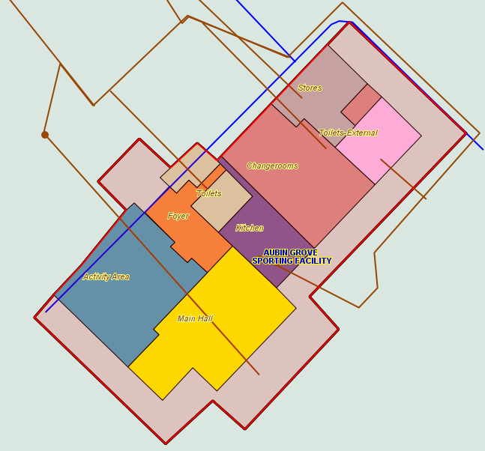

GIS view of Building Structure (Building & Functional Areas)

1. Works system to capture service levels and risk for Planned and Reactive maintenance activities.
2. Maintenance processing functionality for scheduled/planned maintenance.
3. System reporting including AMP related data extracts and reports.
4. eContractor – Increasing visibility and communication with contracted staff.
5. Work Management Mobility.
6. Scheduling of Inspections and defect management.

## 7.4.7 Marine & Coastal Asset Management System (Work System Only)

Development and Implementation of a Work Management System to capture operational asset management activities for a range of Marine & Coastal Assets (Sea/Break Water walls, Gangways, Piles, Service Lines & Points)

**Additional Functionality and Benefits:**

1. Operational Register developed in GIS and Technology One.



GIS Aerial View of Marine Assets (Points, Lines & Polygons)

1. Works system to capture service levels and risk for Planned and Reactive maintenance activities.
2. Maintenance Processing functionality for scheduled/planned maintenance.
3. System reporting including AMP related data extracts and reports.
4. Scheduling of Inspections and defect management.
5. eContractor – Increasing visibility and communication with contracted staff.

# Summary of Community Consultation

Whilst the Asset Management Strategy did not engage in community consultation directly the City’s Asset Management Planning Framework utilises internal and external Customer Satisfaction surveys to assist to guide the setting of service levels that are key to the management and maintenance of the City’s assets. The application and consultation of the Strategy is effectively internal to the City’s corporate and operational areas of business with minimal external stakeholder and public interface.

# Resourcing the Plan

The Asset Management Strategy has identified four major objectives that will be managed and delivered internally by the Asset Services Team, assisted by a proposed financial outlay of approximately $1m in capital funds across the strategy timeframe (2017 - 2018 to 2023 - 2024) for a range of services and products required to achieve the objectives outlined below.

As at December 2017 the projected budgets for the Project & Implementation of the Asset Management Strategies Objectives and Plans are not incorporated into the City’s current [2016 - 2026](https://ab-prd-das-02.cockburn.wa.gov.au:8080/dwroot/datawrks/stores/default/default/orig/docsetid/4709469/currentflag/1/dw_get) Long Term financial Plan, however as the LTFP is due for review and re-adoption in the 2nd quarter of 2018 the intent is for the required funding to be incorporated.

## 9.1 Mobility Field Based Equipment Provision & Replacement

The City is committed to modernising and providing technology to its operational workforce and this will be further reinforced with the continued funding and provision of mobile technology and infrastructure providing greater efficiencies and real time services to the Community.

The estimated replacement cost is based on capital funding, however the preference moving forward would be to seek ownership from Information Services so that provision of all future tablet replacements are managed via lease agreement similar to the majority of the City’s ICT Infrastructure.

**Estimated Mobility Infrastructure Budget**

|  |  |  |  |
| --- | --- | --- | --- |
| **Tablet Replacement Program (No)** | **Replacement Year** | **Funding Status** | **Estimated budget for replacement ($)** |
| 19 | 2019 - 2020 | Planned | 76,000 |
| 10 | 2020 -2021 | Planned | 41,000 |
| 6 | 2021- 2022 | Planned | 25,200 |
| 6 | 2022- 2023 | Planned | 25,800 |
| 19 | 2023 - 2024 | Planned | 83,600 |
| **Estimated Budget required ($)** | | | **251,600** |

The estimated budget for replacement is based on the purchase cost of $4,000 per device from 2019/20 with increments of $100 per device thereafter.

## 9.2 Continued Implementation and Development of the Technology Asset Management Information System (AMIS)

The AMIS is reaching its final years of its Major Development phase with the implementation of a Strategic Asset Management (SAM) system being recognised as the remaining unfunded key element from the City’s 10 year Implementation Strategy.

Beyond the spend detailed below it is largely expected that from 2020 - 2021 that unless new functionality and/or technology becomes available from Technology One the ongoing enhancement and development of the City’s AMIS will be resourced internally with minimal capital expenditure anticipated.

**Estimated AMIS Development Budget.**

|  |  |  |  |
| --- | --- | --- | --- |
| **Project Description** | **Delivery Year** | **Funding Status** | **Estimated Budget ($)** |
| Electronic Timesheets for Roads and Facilities (OP Capture) | 2017 - 2018 | Internal Skills & Resources | 0 |
| E-contractor Management | 2017 - 2018 | Secured 2016/17 | 30,000 |
| Facilities Asset Management System (Register & Work System) | 2017 - 2018 | Internal Skills & Resources | 0 |
| Project Portfolio Management System Implementation (PPM)* | 2017 - 2018 & 2018 - 2019 | Secured 2016/17 | 290,000 |
| Continued rollout off Mobility, including GIS access | 2017 - 2018 | Internal Skills & Resources | 0 |
| Marine & Coastal Asset Management System (Register & Work System) | 2018 - 2019 | Internal Skills & Resources | 0 |
| Strategic Asset Management (SAM)** | 2018 -2019 & 2019 -2020 | Planned | 190,000 |
| **Estimated Budget required ($)**  **(extra to funds already secured)** | **190,000** | | |

* Corporate implementation not solely related to the development of the AMIS.  
** Estimated Budget is calculated on sole purchase of product and licensing.

## 9.3 Asset Condition Surveys – Estimated Cost as at December 2017

Future funding for Asset condition surveys are scheduled in line with the City’s Asset Management Plan development cycle, ensuring that the asset data is accurate, timely and reliable for the purpose of supporting the development of 10 year renewal projections for the City’s LTFP and 4 year rolling capital programs.

**Estimated Asset Condition Surveys Budget**

|  |  |  |  |
| --- | --- | --- | --- |
| **Asset Class** | **Audit Year** | **Funding Status** | **Estimated budget ($)** |
| Buildings Infrastructure | 2018 - 2019 | Secured* | 90,000 |
| Marine & Coastal Infrastructure | 2018 - 2019 | Secured* | 30,000 |
| Parks Hard Infrastructure | 2018 - 2019 | Secured* | 80,000 |
| Road & Footpath Infrastructure | 2018 - 2019 | Planned | 120,000 |
| Buildings Infrastructure | 2022 - 2023 | Planned | 100,000 |
| Marine & Coastal Infrastructure | 2022 - 2023 | Planned | 40,000 |
| Parks Hard Infrastructure | 2022 - 2023 | Planned | 90,000 |
| Road & Footpath Infrastructure | 2022 - 2023 | Planned | 130,000 |
| **Estimated Budget required ($)**  **(extra to funds already secured)** | **480,000** | | |

* Secured during 2017 - 2018 budget with the funds being carried forward.

The estimated budget for each audit is based on actual costs from previous surveys and reflects the City’s ongoing asset infrastructure growth.

## 9.4 Asset Management Benchmarking Audit

The intent is to seek future funding to carry out an independent assessment of all aspects of the City’s asset management practices, which will consist of internal workshops, interviews, evaluation and a report being developed collating the findings of the audit and key recommendations for the future of Asset Management at the City.

**Estimated Asset Management Benchmarking Audit Budget**

|  |  |  |  |
| --- | --- | --- | --- |
| **Project Description** | **Delivery Year** | **Funding Status** | **Estimated Budget ($)** |
| Asset Management Benchmarking Audit | 2020 -2021 | Planned | 20,000 |
| **Estimated Budget required ($)** | **20,000** | | |

# Measuring Achievement / Performance Measures

To assess the effectiveness of the Strategy, four major objectives have been identified for action and completion. For each objective various milestones and performance criteria has been established to enable effective reporting and measurement over the life of the Strategy.

For further information on each of the Major Objectives please refer to Section 7.

## 10.1 Asset Management Plan Development

Existing AMP’s will be re-developed internally by Asset Services in consultation with relevant Senior and Operational Managers twice over the life of the Strategy for the periods of 2017 - 2018 to 2019 - 2020 and 2020 -2021 to 2023 -2024.

Additionally, a new Asset Management Plan for Cockburn ARC will be developed for the period of 2020 - 2021 to 2023 - 2024.

## 10.2 Completion of Infrastructure Asset Condition Surveys

Funding will be sought for financial years 2018 - 2019 and 2022 - 2023 to carry out external condition surveys for the following Asset Classes:

## Buildings Infrastructure*

## Marine & Coastal Infrastructure*

## Parks Hard Infrastructure*

## Road & Footpath Infrastructure

* Budget secured during 2017 -2018 and will be carried forward into 2018 - 2019.

## 10.3 Completion of an Asset Management Continuous Improvement and Benchmarking Audit

Provision of an independent resource to audit, assess and benchmark the City’s Strategic and Operational asset management practices. This initiative will determine the future direction and funding requirements required for future strategies.

## 10.4 Further Implementation and Development of Technology One Asset Management Information System (AMIS)

|  |  |  |
| --- | --- | --- |
| **Project Description** | **Delivery Year** | **Measure of Achievement** |
| Electronic Timesheets for Roads and Facilities (OP Capture) | 2017 - 2019 | Implementation |
| Facilities Asset Management System (Work Management System only) | 2017 - 2018 | Implementation |
| E-contractor Management | 2017 - 2019 | Implementation across all Engineering & Works Contractors |
| Project Portfolio Management System Implementation (PPM) | 2017 - 2019 | Implementation |
| Continued rollout off Mobility, including GIS access in the field and in field asset data access and updating. | 2017 - 2018 | Implementation for all Operational teams within the Engineering & Works with functionality developed to capture all assets constructed through Internal Capital Works programs |
| Marine & Coastal Asset Management System (Work Management System only) | 2017 - 2018 | Implementation |
| Strategic Asset Management (SAM)  (Prediction Modelling & Optimisation) | 2018 - 2020 | Implementation and embedded into the development of the 2020 - 2021 to 2023 - 2024 AMP and 4 year rolling capital renewal programs from 2021. |

# Reporting format

Reporting of achievements from this strategy will be via reporting in the Annual

Report, via the Annual Business Plan and as part the Engineering &

Works Directorate bi-monthly project updates.

Additionally, following the completion of the 4 major Objectives/Plans

detailed in section 10 most notably the completion of the Asset Management

Benchmarking Audit the Asset Management Strategy will be subject to a

comprehensive review during 2021 - 2022 which will inform the future direction of Asset Management practices and procedures across the Organisation and shape future AM Strategies and proposed funding requirements.

# Reference and Demographic Information

1. [Strategic Community Plan 2016 - 2026](https://ab-prd-das-02.cockburn.wa.gov.au:8080/dwroot/datawrks/stores/default/default/orig/docsetid/4699109/currentflag/1/dw_get)
2. Asset Management Policy
3. Project Brief Project Portfolio Management - June 2017
4. Risk Management Framework
5. Asset Management Planning Framework
6. Technology One: eContractor Factsheet
7. Technology One: SAM Prediction Modelling & Optimisation Factsheet
8. International Infrastructure Management Manual

# Definitions

|  |  |
| --- | --- |
| **AMIS** Asset Management Information System | **GIS** Geographical Information System |
| **AMP** Asset Management Plan | **LG** Local Government |
| **AMS** Asset Management Strategy | **ISO55000** An international standard covering management of physical assets |
| **ASPEC** The key objective of the specifications is to record and provide "As Constructed" digital data in a GIS ready format | **ISO31000** An international standard providing principles and generic guidelines on risk management. |
| **DSPEC** As constructed digital asset data specification Drainage Infrastructure | **ICT** Information, Communication and Technology |
| **OSPEC** As constructed digital asset data specification Open space Hard Infrastructure | **LTFP** Long Term Financial Plan |
| **RSPEC** As constructed digital asset data specification for Road & footpath Infrastructure | I**IMM** International Infrastructure Maintenance Manual |
| **PPM** Project Portfolio Management | **CRC** Current Replacement Cost |
| **B/U** Business Unit | **S/U** Service Unit |



**City of Cockburn**

9 Coleville Crescent, Spearwood WA 6193

PO Box 1215, Bibra Lake DC Western Australia 6965

T: 08 9411 3444 F: 08 9411 3333

E: [tgreen@cockburn.wa.gov.au](mailto:tgreen@cockburn.wa.gov.au)

cockburn.gov.wa.au