Tender Title: |  | RFT 17/2022  Provision of Window Cleaning Services – City of Cockburn Properties
Request ID: |  | 46422
Tender Description: |  | The City of Cockburn (The Principal) is seeking the services of an experienced window cleaning contractor for the provision of window cleaning services at the Principal’s buildings and properties.
Advert Approval: |  | Decision to Advertise: Chief Operations Officer  Decision Date: Friday, 30 September 2022
Closing Date and Time: |  | 2:00PM (AWST) Thursday, 27 October 2022
Opening Date and Time: |  | 2:00PM (AWST) Thursday, 27 October 2022
 | Tenderer’s Name:
1 | Armstrong Shine Group Pty Ltd
2 | Du Clene Pty Ltd (Perth)
3 | OCS Services Pty Ltd
4 | SKG Cleaning Pty Ltd
5 | DRD Partnership t/a Southern Cross Cleaning
6
7
8
9
10

Advertisement
Method 1: City of Cockburn | Method 2: Yammer
Method 3:  The Western Australian,  Wednesday, 5th of October 2022 | Tender Awarded by:
Copy of Statewide Notice:  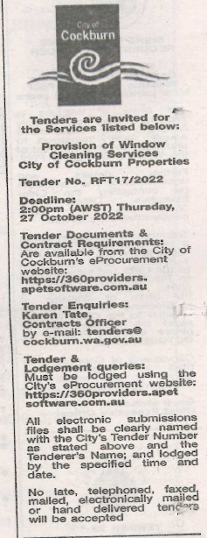 | Chief Operations Officer  Monday, 16 January 2023
 | Date of Council Meeting:
 | Not applicable
Name of Successful Tenderer(s): | DRD Partnership t/a  Southern Cross Cleaning
Amount of Successful Tender(s): (ex GST) | $204,066

