11 August 2023

**Coogee Live 2023 nominee in prestigious Australian Event Awards**

Main points:

* Coogee Live 2023 is a nominee in the prestigious Australian Event Awards for the second time in three years
* The much-loved free community event took out the Best Community Event category at the Australian Event Awards and Symposium in 2021

The City of Cockburn’s weekend-long outdoor festival Coogee Live 2023 is a nominee in the prestigious Australian Event Awards for the second time in two years.

The much-loved free community event took out the Best Community Event category at the Australian Event Awards and Symposium in 2021.

The festival of art and culture is a family-friendly celebration of community, diversity and connection, held along a 1.5km stretch of Coogee Beach.

The 2023 event, the City’s fifth, attracted 26,000+ visitors and was staged in collaboration with Hilton-based Butler & Brown Events.

It featured 180 program elements appealing to people of all ages, cultures and abilities.

A highlight was the Radiate concert featuring Perth Symphony Orchestra and VisAbility WA’s Grand Delusions, a band comprising musicians and performers with vision impairment and acquired brain injury.

This year’s festival kicked off with a unique Great Mermaid Migration which lured 67 merfolk and hundreds of mermaid-mad onlookers, many children, to Coogee Beach.

First Nations traditions and art were shared and celebrated in many forms including yarning sessions with an Elder, Nyungar singing by local school students and a melding of sand art and storytelling that culminated in a dance at dusk.

Students from eight local schools were embraced in a variety of entertaining art-based incursions before and during the event, including lantern-making workshops and a sunset lantern parade along the beach.

Other elements included art and exercise-based activities to promote mental health, some audio described tours and lots of roles for volunteers of all ages.

Other popular offerings included a kitchen garden where the area’s passion for food and historic links to market gardening and fishing were celebrated with healthy cooking demonstrations and waterwise gardening workshops.

The City’s partnerships with sustainable providers supported its waste education and events teams which strived to create a waste wise event, resulting in less than 150kg of landfill created across the two days.

About 580kgs of recyclable and compostable waste and a record-breaking 32,000+ food containers and cutlery were diverted from landfill in keeping with the City’s wastewise events policy.

The low-waste, no single-use plastic event began with a ban on the 80 bins usually located along the 1.5km coastal stretch, replaced with educators at dedicated waste sorting stations to help festival-goers sort items for disposal.

A carbon neutral event, the City offset the event’s carbon emissions by investing in planting a mix of native species equivalent to 50 tonnes of Biodiverse Reforestation Carbon offsets.

City of Cockburn Head of Library and Cultural Services Brittany Cover said the event showcased Cockburn’s strong community culture along with the City’s attractiveness to visitors from far and wide.

“The popular festival engenders and builds on the sense of pride and belonging in the diverse Cockburn community,” Ms Cover said.

“We have drawn upon our unique community to grow this award-winning event which is a significant element of its success and vibrancy. The City’s high-quality events are just another reason why people are seeking out Cockburn.

“Cockburn is the best place to be and more people are demonstrating that every year by voting with their feet and coming along to Coogee Live along our fantastic coastline.”

The Australian Event Awards & Symposium will be held in Sydney on 13 September.

ENDS

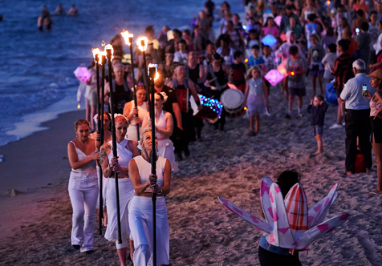

For more information contact:  
Media and Communications Officer  
City of Cockburn  
T: 08 9411 3551  
E: media@cockburn.wa.gov.au