Tender Title: |  | RFT 15/2022  Collection Services (Recycling/Delivery) Mattresses, Electronic Waste & Metal Products
Request ID: |  | 46394
Tender Description: |  | The City of Cockburn are seeking the services of a recycling contractor to collect and recycle mattresses from Henderson Waste Recovery Park and from verges in various streets within the City as well as collection of Electronic Waste (Televisions, Computers, Printers)
Advert Approval: |  | Decision to Advertise: Chief Financial Officer  Decision Date: Friday, 23 September 2022
Closing Date and Time: |  | 2:00PM (AWST) Tuesday, 25 October 2022
Opening Date and Time: |  | 2:00PM (AWST) Tuesday, 25 October 2022
 | Tenderer’s Name:
1 | Community Resources Limited t/a Great Lakes Community Resources Inc. (Soft Landing)
2
3
4
5
6
7
8
9
10

Advertisement
Method 1: City of Cockburn | Method 2: Yammer
Method 3:  The Western Australian,  Wednesday, 28th of September 2022 | Tender Awarded by:
Copy of Statewide Notice:  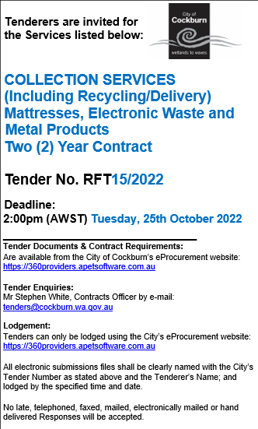 | Chief Operations Officer  Tuesday, 1 November 2022
 | Date of Council Meeting:
 | Not applicable
Name of Successful Tenderer(s): | Great Lakes Community Resources Inc. (Soft Landing WA)
Amount of Successful Tender(s): (ex GST) | $480,000

