Tender Title: |  | RFT 08/2023  Glazing Services – Supply of Glazing Services to City of Cockburn Facilities
Request ID: |  | 46926
Tender Description: |  | The City of Cockburn (the Principal) is seeking a suitably qualified experienced and licensed Contractor to undertake the supply of Glazing Services at the Principal’s buildings and properties.
Advert Approval: |  | Decision to Advertise: Chief Operations Officer  Decision Date: Thursday, 13 April 2023
Closing Date and Time: |  | 2:00PM (AWST) Tuesday, 9 May 2023
Opening Date and Time: |  | 2:00PM (AWST) Tuesday, 9 May 2023
 | Tenderer’s Name:
1 | Action Glass & Aluminium
2 | The Trustee for Cobber Trust t/a Imperial Glass
3 | Reads West Coast Maintenance t/a Rockingham Glass
4
5
6
7
8
9
10

Advertisement
Method 1: City of Cockburn | Method 2: Yammer
Method 3:  The Western Australian,  Wednesday, 19th April 2023 | Tender Awarded by:
Copy of Statewide Notice:  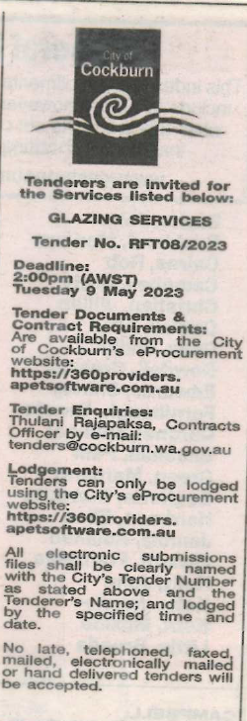 | Chief Operations Officer  Thursday, 29 June 2023
 | Date of Council Meeting:
 | Not applicable
Name of Successful Tenderer(s): | Reads West Coast Maintenance Pty Ltd t/a Rockingham Glass
Amount of Successful Tender(s): (ex GST) | $151,875

