Tender Title: |  | RFT 01/2023  Landscape Maintenance Services – North Coogee  (Parks & Streetscapes)
Request ID: |  | 46780
Tender Description: |  | The City of Cockburn (the Principal) is seeking a suitably qualified and experienced Contractor to conduct scheduled landscape maintenance of parks and streetscapes in the suburb of North Coogee.
Advert Approval: |  | Decision to Advertise: Chief Operations Officer  Decision Date: Tuesday, 7 February 2023
Closing Date and Time: |  | 2:00PM (AWST) Thursday, 9 March 2023
Opening Date and Time: |  | 2:00PM (AWST) Thursday, 9 March 2023
 | Tenderer’s Name:
1 | LD Total
2 | Gecko Contracting Turf and Landscape Maintenance
3 | Horizon West Landscape & Irrigation
4 | Landscape Elements (Construction)
5 | Landscape Australia
6
7
8
9
10

Advertisement
Method 1: City of Cockburn | Method 2: Yammer
Method 3:  The Western Australian,  Wednesday, 15th February 2023 | Tender Awarded by:
Copy of Statewide Notice:  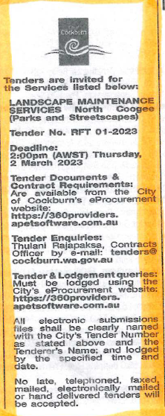 | Chief Operations Officer  Chief Financial Officer  Wednesday, 3 May 2023
 | Date of Council Meeting:
 | Not applicable
Name of Successful Tenderer(s): | Landscape Elements Pty Ltd (Construction)
Amount of Successful Tender(s): (ex GST) | $818,113.50

