24 November 2023

**City of Cockburn website recognised as Australia’s best**

The City of Cockburn has the most accessible website in Australia.  
  
The City won two awards at the Australian Access Awards 2023, held biennially by the Centre for Accessibility Australia, on 22 November.  
  
Up against high calibre national competitors, the City was named joint winner of the overall Website of the Year, sharing the honour with Deafblind Information Australia, and also took out the Government Website of the Year title.  
  
The City beat out 18 other top-notch national finalists in the government website category including the Children’s Court of WA, the Australian Bureau of Statistics, the Brisbane and Melbourne city councils, ABC iView, the WA and Victorian governments and Accessibility NSW.  
  
With stiff competition from finalists in several categories, including awards for corporate websites and apps won by Telstra and Bendigo Bank, the City’s vision to create a website where information is accessible to the whole Cockburn community is paying off.  
  
The City’s website has almost a million visits every year and has been accredited under the international Web Content Accessibility Guidelines (2.1 Level AA), developed by the World Wide Web Consortium (W3C), since 2017.  
  
Mayor Logan Howlett said the well-deserved awards were the culmination of seven years’ work for the City’s web partnership comprising members of the City’s Communications and Marketing, and Business Systems teams.  
  
“Having an accessible website not only helps people with disability access important information, but people with low literacy levels, the elderly and the many members of our community who are culturally and linguistically diverse,” Mayor Howlett said.  
  
“Cockburn is the most culturally diverse council in the Perth southern metropolitan area with one in every two residents from a culturally diverse background, with either themselves or their parents born overseas.  
  
“While so many websites can be hard to navigate, ensuring we improve how City information can be accessed and consumed is vital to promoting equitable access for all.”  
  
The City is guided by its Disability and Access Inclusion Plan 2023-2028 (DAIP), the Website Policy and the Website Governance and Content Management Plan (WGCMP).  
  
City of Cockburn Disability Access and Inclusion Officer Ben Rowe said planning for website accessibility started many years ago when the DAIP mandated the employment of an accessibility consultant when the City created its new website in 2016.  
  
“One Outcome listed in the DAIP is that people with disability receive information from the City in a format that will enable them to access it as readily as other people,” Mr Rowe said.  
  
“We do this by continuing to improve the website and mobile accessibility in line with W3C recommendations, and considering accessibility when procuring new software, hardware and other City systems.”  
  
The WGCMP ensures the City meets accessibility challenges with ongoing reviews and tests new website developments to continue meeting community need.  
  
“City staff have monthly website meetings to discuss content reviews and fortnightly website team meetings to discuss all projects, with accessibility a regular topic,” Mr Rowe said.  
  
“They also continue to reduce PDFs on the website, with the aim of converting them to HTML, as PDFs are inaccessible to people who use screen readers, and are very difficult to read on mobile phones.”  
  
**Caption:** City of Cockburn Disability Access and Inclusion Officer Ben Rowe pictured with the Disability Access and Inclusion Plan 2023-2028.

ENDS

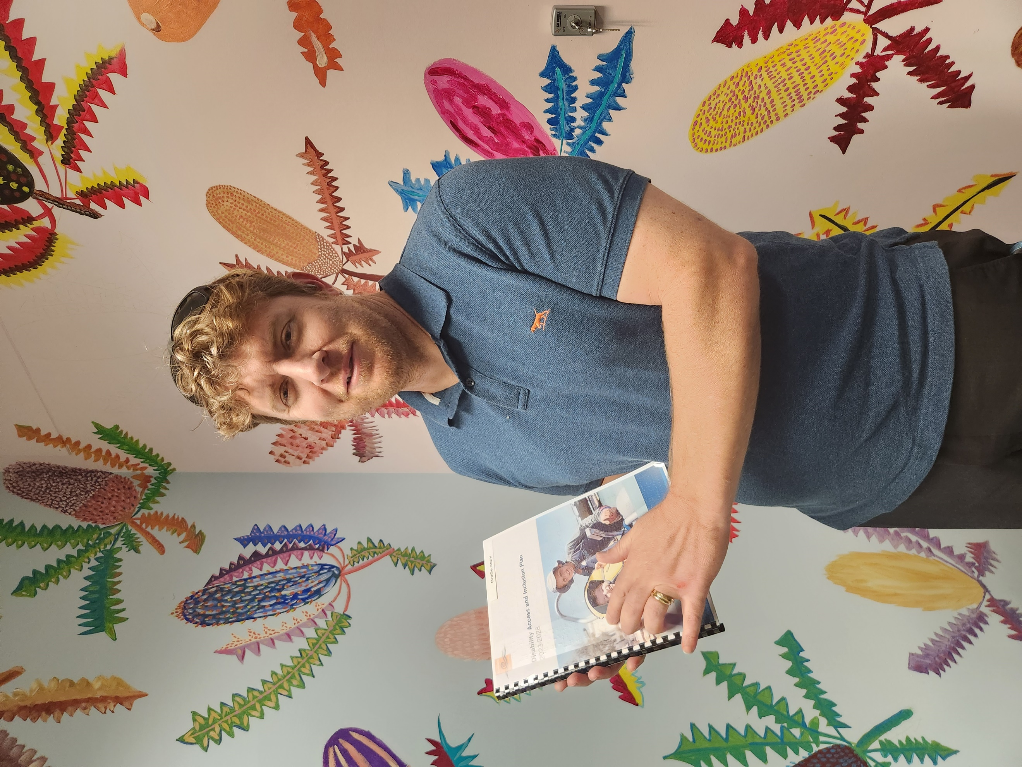

For more information contact:  
Media and Communications Officer  
City of Cockburn  
T: 08 9411 3551  
E: media@cockburn.wa.gov.au