Tender Title: |  | RFT 16/2022  Road Planing (Cold) Services
Request ID: |  | 46394
Tender Description: |  | The City of Cockburn is seeking the services of suitably qualified and experienced Road Planing Contractor for the Principal’s cold road planning requirements at locations throughout the City of Cockburn area.
Advert Approval: |  | Decision to Advertise: Chief Operations Officer  Decision Date: Wednesday, 21 September 2022
Closing Date and Time: |  | 2:00PM (AWST) Tuesday, 18 October 2022
Opening Date and Time: |  | 2:00PM (AWST) Tuesday, 18 October 2022
 | Tenderer’s Name:
1 | Dowsing Group Pty Ltd
2 | Kee Surfacing Pty Ltd
3 | West Coast Profilers Pty Ltd
4
5
6
7
8
9
10

Advertisement
Method 1: City of Cockburn | Method 2: Yammer
Method 3:  The Western Australian,  Saturday, 24th September 2022 | Tender Awarded by:
Copy of Statewide Notice:  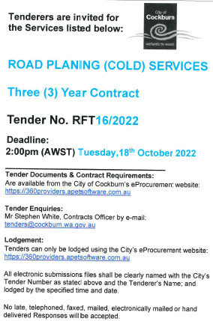 | Chief Operations Officer  Chief Financial Officer  Monday, 19 December 2022
 | Date of Council Meeting:
 | Not applicable
Name of Successful Tenderer(s): | Dowsing Group Pty Ltd
Amount of Successful Tender(s): (ex GST) | $504,259

