Tender Title: |  | RFT 04/2023  Bakers Square Netball Courts Upgrade – Hamilton Hill
Request ID: |  | 46818
Tender Description: |  | The City of Cockburn (the Principal) is seeking a suitably qualified and experienced construction contractor to construct the Baker Square Netball Court Project in the west suburb, Hamilton Hill, WA 6163.
Advert Approval: |  | Decision to Advertise: Chief Operations Officer  Decision Date: Thursday, 23 February 2023
Closing Date and Time: |  | 2:00PM (AWST) Wednesday, 22 March 2023
Opening Date and Time: |  | 2:00PM (AWST) Wednesday, 22 March 2023
 | Tenderer’s Name:
1 | Menchetti Consolidated Pty Ltd t/a MP Group (WA)
2 | Solution 4 Building Pty Ltd
3
4
5
6
7
8
9
10

Advertisement
Method 1: City of Cockburn | Method 2: Yammer
Method 3:  The Western Australian,  Wednesday. 1st March 2023 | Tender Awarded by:
Copy of Statewide Notice:  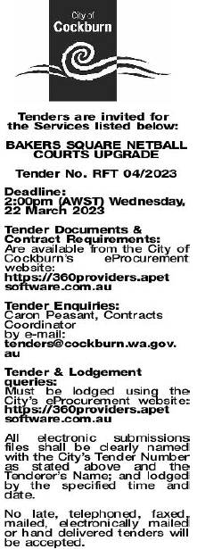 | Chief Operations Officer  Wednesday, 13 September 2023
 | Date of Council Meeting:
 | Not applicable
Name of Successful Tenderer(s): | N/A
Amount of Successful Tender(s): (ex GST) | Non-Award

