Tender Title: |  | RFT 10/2023  Shade Sails – Installation, Removal, Storage & Repairs
Request ID: |  | 47054
Tender Description: |  | The City of Cockburn (The Principal) is seeking a suitably qualified and experienced Contractor for summer installation and winter removal, storage and repairs of Shade Sails at various parks, playgrounds and community centres across the Principals area of responsibility.
Advert Approval: |  | Decision to Advertise: Chief Operations Officer  Decision Date: Tuesday, 2 May 2023
Closing Date and Time: |  | 2:00PM (AWST) Wednesday, 31 May 2023
Opening Date and Time: |  | 2:00PM (AWST) Wednesday, 31 May 2023
 | Tenderer’s Name:
1 | The Trustee for Lucwambu Discretionary Trust t/a Perth Better Homes
2 | West Coast Shade
3
4
5
6
7
8
9
10

Advertisement
Method 1: City of Cockburn | Method 2: Yammer
Method 3:  The Western Australian,  Wednesday, 10th May 2023 | Tender Awarded by:
Copy of Statewide Notice:  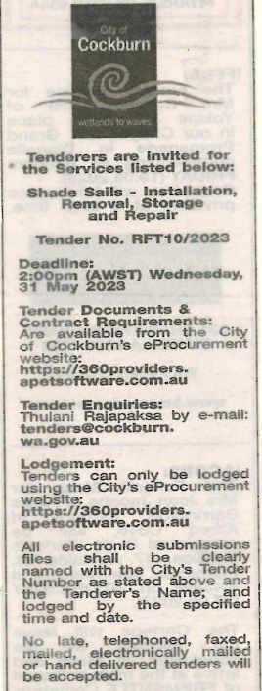 | Chief Operations Officer  Thursday, 13 July 2023
 | Date of Council Meeting:
 | Not applicable
Name of Successful Tenderer(s): | Lucwambu Discretionary Trust t/a Perth Better Homes
Amount of Successful Tender(s): (ex GST) | $350,478

