Tender Title: |  | RFT 02/2024 – CONSTRUCTION SERVICES – SANTICH PARK UPGRADE
Request ID: |  | 49596
Tender Description: |  | The City of Cockburn is seeking the services of a suitably qualified and experienced Civil Contractor to undertake the supply, delivery, installation and commissioning of Sports Floodlighting, a carpark and associated works at Santich Park, Lake Coogee, Western Australia.
Advert Approval: |  | Decision to Advertise: Chief Operations Officer  Decision Date: Monday, 22 January 2024
Closing Date and Time: |  | 2:00PM (AWST) Wednesday, 21 February 2024
Opening Date and Time: |  | 2:00PM (AWST) Wednesday, 21 February 2024
 | Tenderer’s Name:
1 | BOS Civil Pty Ltd
2 | CDI (WA) Pty Ltd
3 | Ertech Pty Ltd
4 | MG Group WA
5
6
7
8
9
10

Advertisement
Method 1: City of Cockburn | Method 2: Yammer
Method 3:  The Western Australian  Wednesday, 24 January 2024 | Tender Awarded by:
Copy of Statewide Notice:  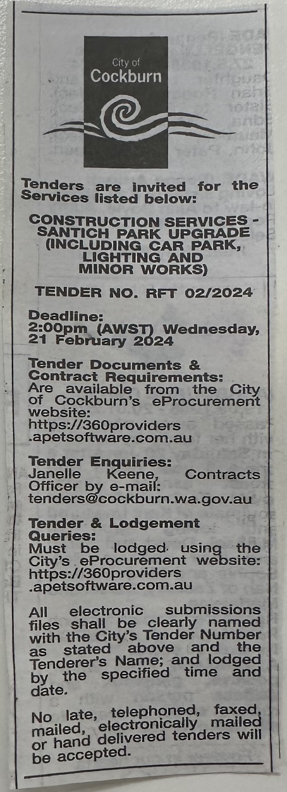 | OCM  Tuesday, 9 April 2024
 | Date of Council Meeting:
Tuesday, 9 April 2024
Minutes: 0050
Item No: 14.2.1
Name of Successful Tenderer(s): | Ertech Pty Ltd
Amount of Successful Tender(s): (ex GST) | $1,315,375.20 Ex GST

