City of Cockburn:
Resource Recovery Calendar 2023-24
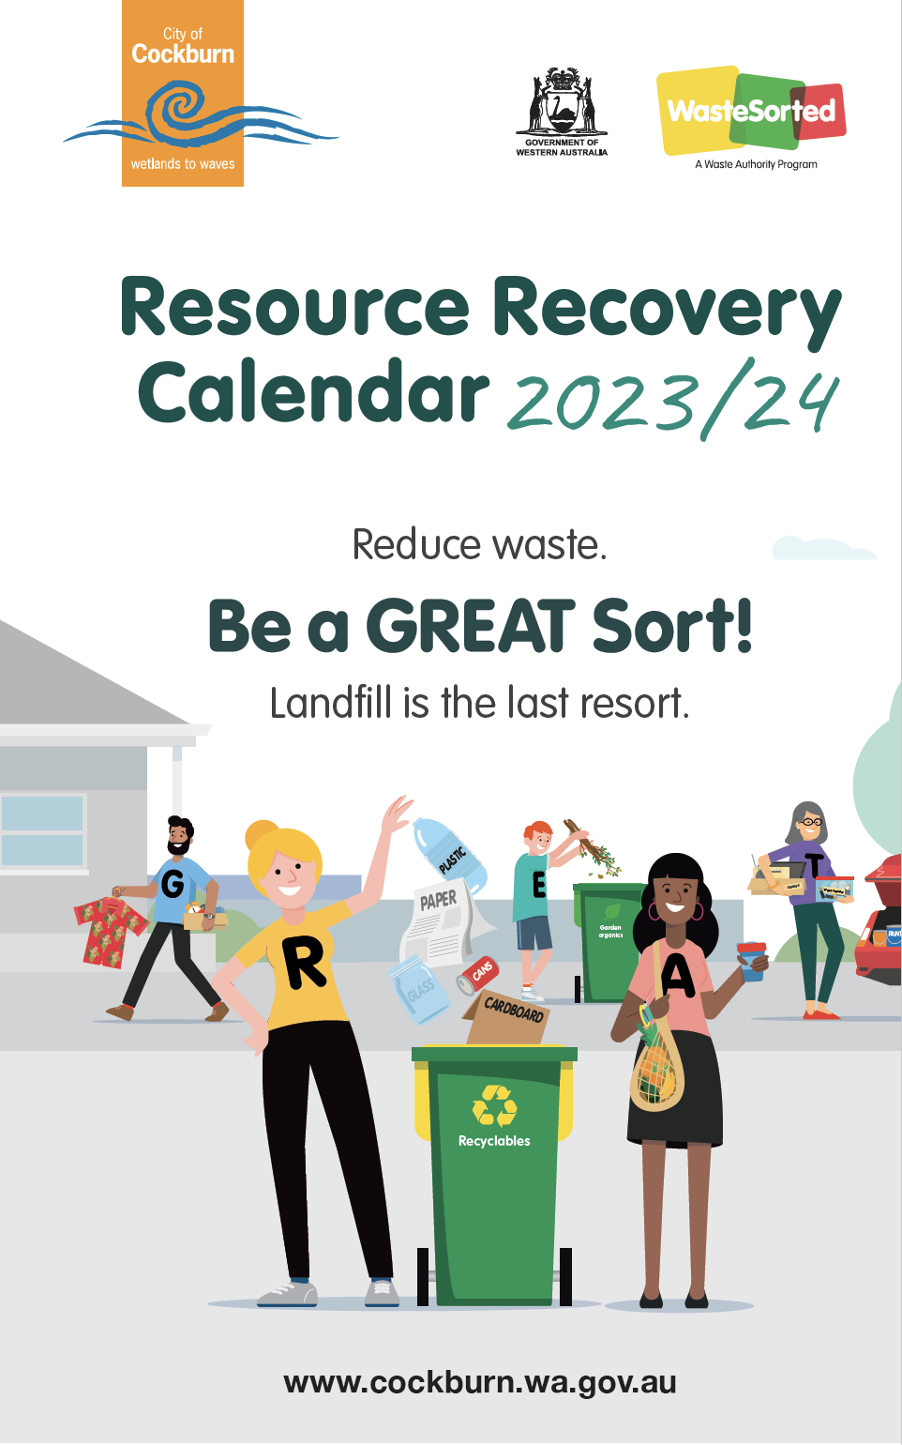
Reduce waste.
Be a Great Sort!
Landfill is the last resort.
City of Cockburn website: www.cockburn.wa.gov.au

Christmas and New Year Bin Collections
Over the festive season, bins will not be collected on Monday, 25 December 2023 or Monday, 1 January 2024.
On these two weeks, everyones bins will be collected one day later than usual.
Monday collections will be on Tuesday, Tuesday collections will be on Wednesday, and so on.

Recycling & General Waste Bin Collection Map
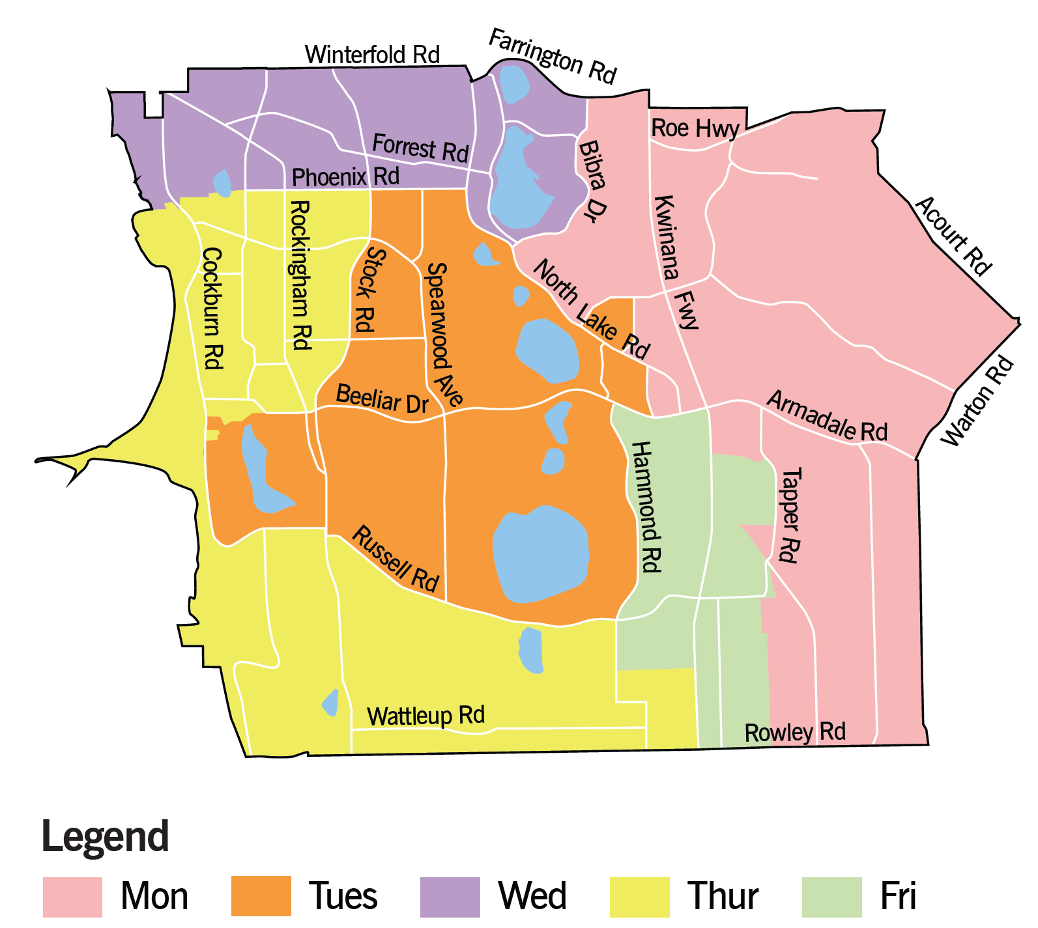
The map above shows the City of Cockburn divided into five areas, each marked with a different colour to show which day recycling and general waste bins are collected in this area.
Monday (pink on map):
This area encompasses a section on the eastern side of the City of Cockburn. Its boundaries include Farrington Road, Acourt Road, Warton Road, Rowley Road, Bibra Drive and North Lake Road. Roe Highway, Kwinana Freeway, Armadale Road and Tapper Road are included in this area.
Tuesday (orange on map):
This area encompasses a section in the middle of the City of Cockburn. Its boundaries include Phoenix Road, North Lake Road, Hammond Road, Russell Road, and Stock Road. Spearwood Avenue and Beeliar Drive are included in this area.
Wednesday (purple on map):
This area encompasses a section on the northern side of the City of Cockburn. Its boundaries include Winterfold Road, Farrington Road, Bibra Drive, and Phoenix Road. Forrest Road is included in this area.
Thursday (yellow on map):
This area encompasses a section on the western and southern side of the City of Cockburn. Its boundaries include Phoenix Road, Stock Road, Russell Road, and Rowley Road. Rockingham Road, Cockburn Road, and Wattleup Road are included in this area.
Friday (green on map):
This area encompasses a section towards the south-eastern side of the City of Cockburn. Its boundaries include Hammond Road, Armadale Road, Tapper Road, and Rowley Road. Kwinana Road and Russell Road are included in this area.
Transcriber’s Note: Please contact City of Cockburn for more information or clarification.

Garden Organics Bin Collection Map
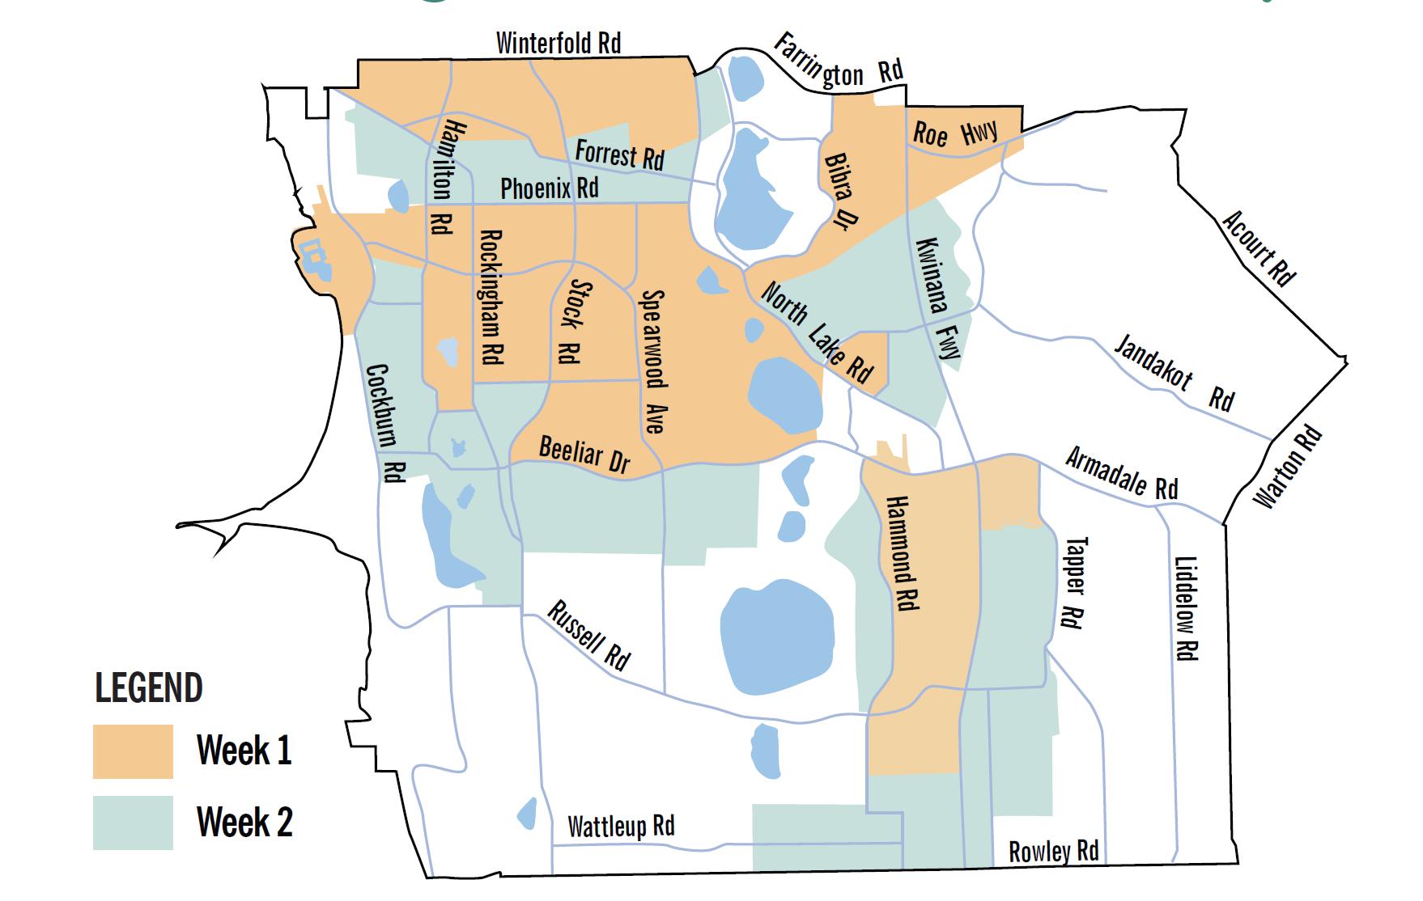
The map above shows the City of Cockburn, marked in two different colours to show which week garden organics bins are collected in that area.
Week 1 (orange on map):
This includes:
- An area on the north-western side of the City of Cockburn. Its boundaries include Winterfold Road and Forrest Road.
- An area extending from the north-eastern side of the City of Cockburn in a western and south-easterly direction. Its boundaries include Farrington Road, Bibra Drive, Phoenix Road, Hamilton Road, Belliar Drive, Hammond Road, and Kwinana Freeway. This area includes Roe Highway, Spearwood Avenue, Stock Road, and Rockingham Road.
Week 2 (green on map):
This includes:
- An area towards the north of the City of Cockburn. Its boundaries include Phoenix Road, Bibra Drive, and Farrington Road.
- A large area much of the eastern, southern and western sides of the City of Cockburn. Its boundaries include Acourt Road, Warton Road, Rowley Road, Beeliar Drive, and Hammond Road. Kwinana Freeway, Jandakot Road, Armadale Road, Liddlelow Road, Tapper Road, Wattleup Road, Russell Road, and Cockburn Road are included in this area.
Transcriber’s Note: Please contact City of Cockburn for more information or clarification.
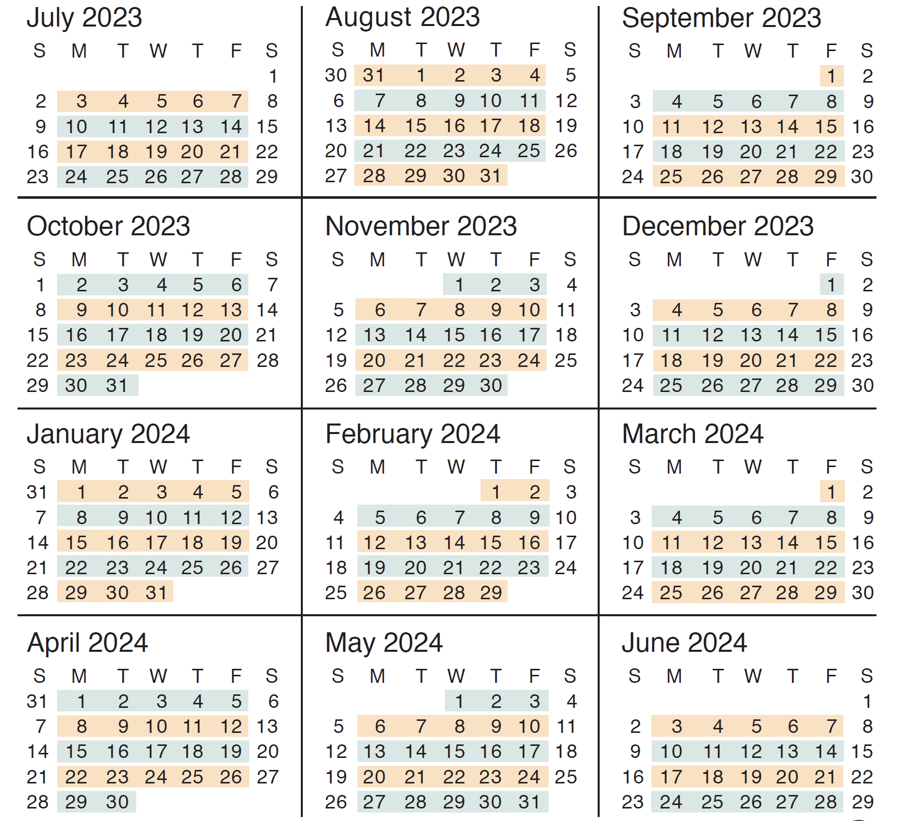
The calendar above covers July 2023 to June 2024. It highlights which week is Week 1 (orange) and which is Week 2 (green) with regards to the garden organics bin collection.
Week 1 begins the week starting Monday, 3 July. Week 2 begins the week starting Monday, 10 July. From there, the weeks alternate for the rest of the financial year.
Transcriber’s Note: Please contact City of Cockburn for more information or clarification.

Your Recycling Bin (Weekly)
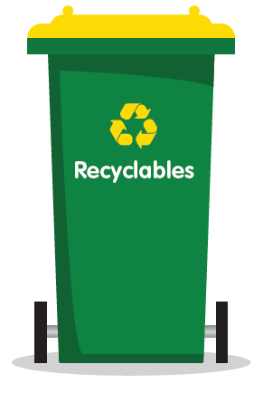
- Hard plastic bottles and containers, aluminium and steel cans, glass bottles and jars, paper and cardboard
- Place items loose in your bin
- Remove lids
- Rinse items
- No batteries or aerosols
- No soft plastics
- No clothing (textiles)
- No polystyrene
- No nappies
- No coffee cups
- No tissues

General Waste Bin (Weekly)
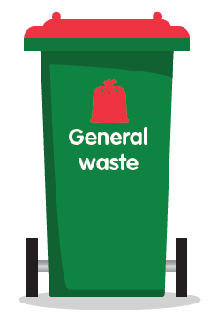
- All food scraps, nappies, hygiene products and other non-recyclable materials
- Garden organics (if you are on the two bin system)
- Soft plastic
- No recyclables
- No batteries, aerosols or chemicals

Your Garden Organics Bin (Fortnightly)
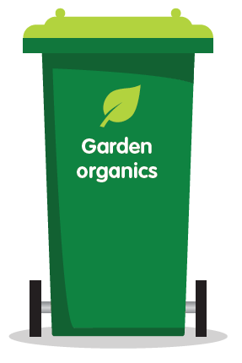
- Only natural materials that grow in the garden can be placed in this bin, including prunings, twigs, lawn clippings etc.
- Branches should be no thicker than 60mm
- No recyclables
- No food waste
- No plastic
- No pet faeces

Lost, stolen or damaged bins?
 If your receptable is lost, stolen or damaged call the City on 08 9411 3444. All damaged bins MUST be on the verge area.

Tips for Using Your Bins
- Place bins out by 6am on the day of collection. Your bins may not be collected at the same time every week
- Place bins within 1.5m of the kerb with bin handles facing towards your property and lid handles facing the road
- Place bins 30cm apart to allow access for the waste truck arm
- Place smaller 140L bin to left hand side of other bins (when viewed from road)
- Do not overfill your bin – the trucks cannot lift bins weighing over 70kg
- Keep bin lids closed to ensure waste doesn’t blow out or spill onto the verge
- Place your bin clear of obstacles e.g. cars, trees or overhanging branches
- Do not place batteries, aerosols, hot ash, liquids, oil, paint or solvents in your bins as they will damage bins, trucks and the environment
- Return bins to your property as soon as possible after they are emptied, within 24 hours
- Except for a reasonable period before and after collection time, keep each receptable in a storage space or area that is behind the street alignment.
- Clean bins regularly
- Alternate collection arrangements can be made to assist frail, aged and disabled residents
- Unpaid or non-Cockburn bins will not be collected.

Bin Placement
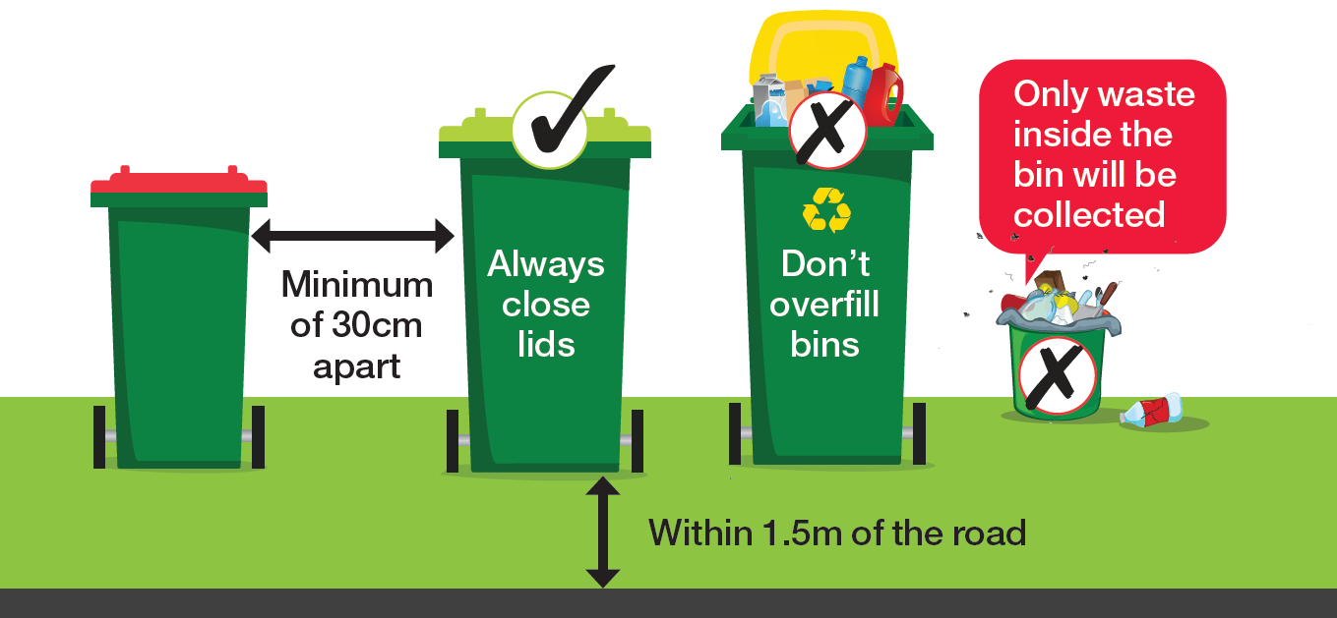
The diagram above illustrates the correct use and placement of your bins:
- Within 1.5 metres of the road
- Minimum of 30 centimetres apart
- Always close lids
- Don’t overfill bins
- Only waste inside the bin will be collected

Resource Recovery Guide
This guide explains where you should dispose of your waste items.
Those marked with an * can be disposed of for free at Henderson Waste Recovery Park.
To find charities accepting donations, visit GIVIT: www.givit.org.au

A
- Acids* – Henderson Waste Recovery Park
- Aerosol cans* – Henderson Waste Recovery Park, City’s libraries, Cockburn ARC or City Administration Building – See page 33
- Aluminium cans – Recycling bin or Container for Change refund point
- Ammonia* – Henderson Waste Recovery Park
- Animal droppings – General waste bin
- Antennas – Hard Waste Collection
- Artificial Turf – General waste bin
- Asbestos – Henderson Waste Recovery Park – See page 33
- Ash (cold) – General waste bin
- Auto Batteries – Henderson Waste Recovery Park or retailer

B
Balloons – General waste bin
Band-Aids – General waste bin
Barbecues – Henderson Waste Recovery Park or Hard Waste Collection
Barbecue charcoal (cold) – General waste bin
Baskets (cane/wooden/plastic) – Henderson Waste Recovery Park or Hard Waste Collection
Batteries* – Henderson Waste Recovery Park or any of the City’s libraries or any Officeworks outlet – See page 33
Beer cartons – Recycling bin
Bicycles and parts – Henderson Waste Recovery Park or Hard Waste Collection
Blankets – Give to charity or general waste bin
Bleaches* – Henderson Waste Recovery Park
Blinds – Henderson Waste Recovery Park or Hard Waste Collection
Blister Packs – General Waste bin
Books – Give to charity or general waste bin
Bottles (plastic/glass) – Recycling bin
Brake fluid* – Henderson Waste Recovery Park
Bricks – Henderson Waste Recovery Park
Broken glass – Recycling bin
Bubble wrap – General waste bin
Building materials/waste – Henderson Waste Recovery Park
Bulky items – Henderson Waste Recovery Park or Hard Waste Collection

C
Candles and wax – General waste bin
Cans (aluminium/steel) – Recycling bin or Container for Change refund point
Cat litter – General waste bin
Cardboard – Recycling bin
Car parts – Henderson Waste Recovery Park
Carpet/underlay – Henderson Waste Recovery Park or Hard Waste Collection
Cartons (juice/milk etc - silver lined or not - Tetra Pak) – General waste bin
Cassette tapes and video tapes – General waste bin
CDs and DVDs – General waste bin
Cellophane – General waste bin
Ceramic (broken plates, tiles, pots) – General waste bin
Cereal boxes – Recycling bin
Chemical drums (triple rinsed)* – Henderson Waste Recovery Park
Christmas decorations – General waste bin
Cigarette butts – General waste bin
Cleaning products* – Henderson Waste Recovery Park
Cling wrap (soiled) – General waste bin
Clothing/fabric (reusable) – Give to charity
Clothing/fabric (not reusable) – General waste bin
Cockroach bait* – Henderson Waste Recovery Park
Coffee cups (disposable) – General waste bin
Coffee jars/cans – Recycling bin
Coffee pods – General waste bin
Compostable packaging – General waste bin
Computer components/accessories* – Henderson Waste Recovery Park
Computer paper – Recycling bin
Concrete – Henderson Waste Recovery Park
Condoms – General waste bin
Cooking fat (solid)– General waste bin
Cork – General waste bin
Cotton wool/buds – General waste bin
Cups and saucers – General waste bin
Cutlery (metal) – General waste bin or give to charity
Cutlery (plastic) – General waste bin
Cutlery (wood) – General waste bin

D
Dirt and soil – Henderson Waste Recovery Park
Disposable nappies – General waste bin
Disposable razors – General waste bin

E
Egg cartons – Recycling bin
Electrical appliances/cables* – Henderson Waste Recovery Park or Hard Waste Collection – Separated
E-Waste* – Henderson Waste Recovery Park or Hard Waste Collection – Domestic quantities – Separated
Electrical equipment – Henderson Waste Recovery Park or Hard Waste Collection – Separated
Envelopes – Recycling bin
EPIRB locator beacons* – Henderson Waste Recovery Park

F
Fertiliser* – Henderson Waste Recovery Park
Fire extinguishers (Red)* – Henderson Waste Recovery Park Yellow fire extingunishers to go to Department of Fire and Emergency Services (DFES)
Flares* – Henderson Waste Recovery Park
Flooring – Henderson Waste Recovery Park
Fly tape – General waste bin
Foil (clean) – Recycling bin
Food scraps – General waste bin or home compost system
Fridges – Henderson Waste Recovery Park or Hard Waste Collection
Furniture (broken) – Henderson Waste Recovery Park or Hard Waste Collection
Furniture (intact) – Give to charity

G
Garden chemicals/poison* – Henderson Waste Recovery Park
Garden waste (small prunings or grass clippings) – General waste bin (two bin system) or garden organics bin (three bin system)
Garden waste (large) – Henderson Waste Recovery Park or Garden Organics Verge Collection
Gas cylinders* – Henderson Waste Recovery Park
Glass bottles/jars – Recycling bin
Glossy magazines/brochures – Recycling bin
Greaseproof paper – General waste bin
Bin Guide (C–G)

H
Hose (garden) – General waste bin when cut in short lengths. Henderson Waste Recovery Park or Hard Waste Collection

I
Ice cream containers (plastic) – Recycling bin
Insecticides* – Henderson Waste Recovery Park

J
Juice bottles (plastic) – Recycling bin
Junk (small items) e.g. brick-a-brac – General waste bin
Junk (too large for bin) – Henderson Waste Recovery Park or Hard Waste Collection
Junk mail – Recycling bin

L
Lids (metal) – Recycling bin
Lids (plastic bottle tops) – General waste bin or recycle at Containers for Change refund points (Container For Change: www.containersforchange.com.au/wa)
Light globes/fluorescent tubes* – Henderson Waste Recovery Park or any of City’s libraries – See page 33

M
Magazines – Recycling bin
Meat trays (coloured or clear) – General waste bin
Meat tray pads – General waste bin
Medicines – Return to pharmacy
Mineral turpentine* – Henderson Waste Recovery Park
Mobile phones – Any of City’s libraries
Motor oil* – Henderson Waste Recovery Park

N
Nappies (disposable) – General waste bin
Needles – Refer to www.healthywa.wa.gov.au
Newspapers – Recycling bin

O
Oil (cooking) – General waste bin
Oil (motor)* – Henderson Waste Recovery Park

P
Paint* – Henderson Waste Recovery Park
Paint tins* – Henderson Waste Recovery Park
Paper (not shredded) – Recycling bin
Paper (shredded) – General waste bin or home compost system
Pens/biros/textas/pencils – General waste bin
Pest control concentrates* – Henderson Waste Recovery Park
Petrol/flammable liquids* – Henderson Waste Recovery Park
Phone books – General waste bin
Picture frames (broken) – General waste bin
Picture frames (intact) – Give to charity
Pizza boxes (clean) – Recycling bin
Pizza boxes (soiled) – General waste bin or home compost system
Pill packets (blister packs, tablet boxes) – General waste bin
Placemats – General waste bin
Plastic containers/punnets – Recycling bin
Plastic containers (large) – Henderson Waste Recovery Park or Hard Waste Collection
Plastic cutlery – General waste bin
Plastic (soft, scrunchable) – General waste bin
Plastic plant pots – General waste bin
Plate glass – Henderson Waste Recovery Park
Poisons (liquid/solid)* – Henderson Waste Recovery Park
Polystyrene (small items) – General waste bin
Polystyrene (large items)* – Henderson Waste Recovery Park
Pool chemicals* – Henderson Waste Recovery Park
Printer cartridges – Any of City libraries

R
Rat poison* – Henderson Waste Recovery Park
Rope – General waste bin when cut in short lengths. Henderson Waste Recovery Park or Hard Waste Collection
Rubber tyres – Henderson Waste Recovery Park

S
Sanitary pads – General waste bin
Seedling containers – General waste bin
Shoes (reusable) – Give to charity
Shoes (not reusable) – General waste bin
Silicone containers and bags – General waste bin
Smoke alarms* – Henderson Waste Recovery Park
Soap – General waste bin
Soil – Henderson Waste Recovery Park

T
Takeaway food containers (plastic) – Recycling bin
Takeaway food containers (polystyrene) – General waste bin
Tampons – General waste bin
Terracotta tiles/pots – General waste bin
Television* – Henderson Waste Recovery Park or Hard Waste Collection – Domestic quantities – Separated
Timber – Henderson Waste Recovery Park or Hard Waste Collection
Timber (treated) – Henderson Waste Recovery Park
Tissues – General waste bin
Toothbrushes – General waste bin
Toothpaste tubes – General waste bin
Toys (broken) – General waste bin
Toys (intact) – Give to charity
Tyres – Henderson Waste Recovery Park

V
Vacuum cleaner dust – General waste bin
Vinyl school bags (broken) – General waste bin
Vinyl school bags (intact) – Give to charity
Other vinyl (kitchen tiles etc) – General waste bin

W
Waxed cardboard – General waste bin
Waxed paper – General waste bin
Weeds – General waste bin (two bin system) or garden waste bin (three bin system)
White goods – Henderson Waste Recovery Park or Hard Waste Collection
Windowpanes – Henderson Waste Recovery Park
Wood (garden prunings) – General waste bin (two bin system) or garden waste bin (three bin system)
Wooden planks/ furniture – Henderson Waste Recovery Park or Hard Waste Collection
Wrapping paper – Recycling bin

X
X-rays* – Henderson Waste Recovery Park
* Free drop-off to Henderson Waste Recovery Park
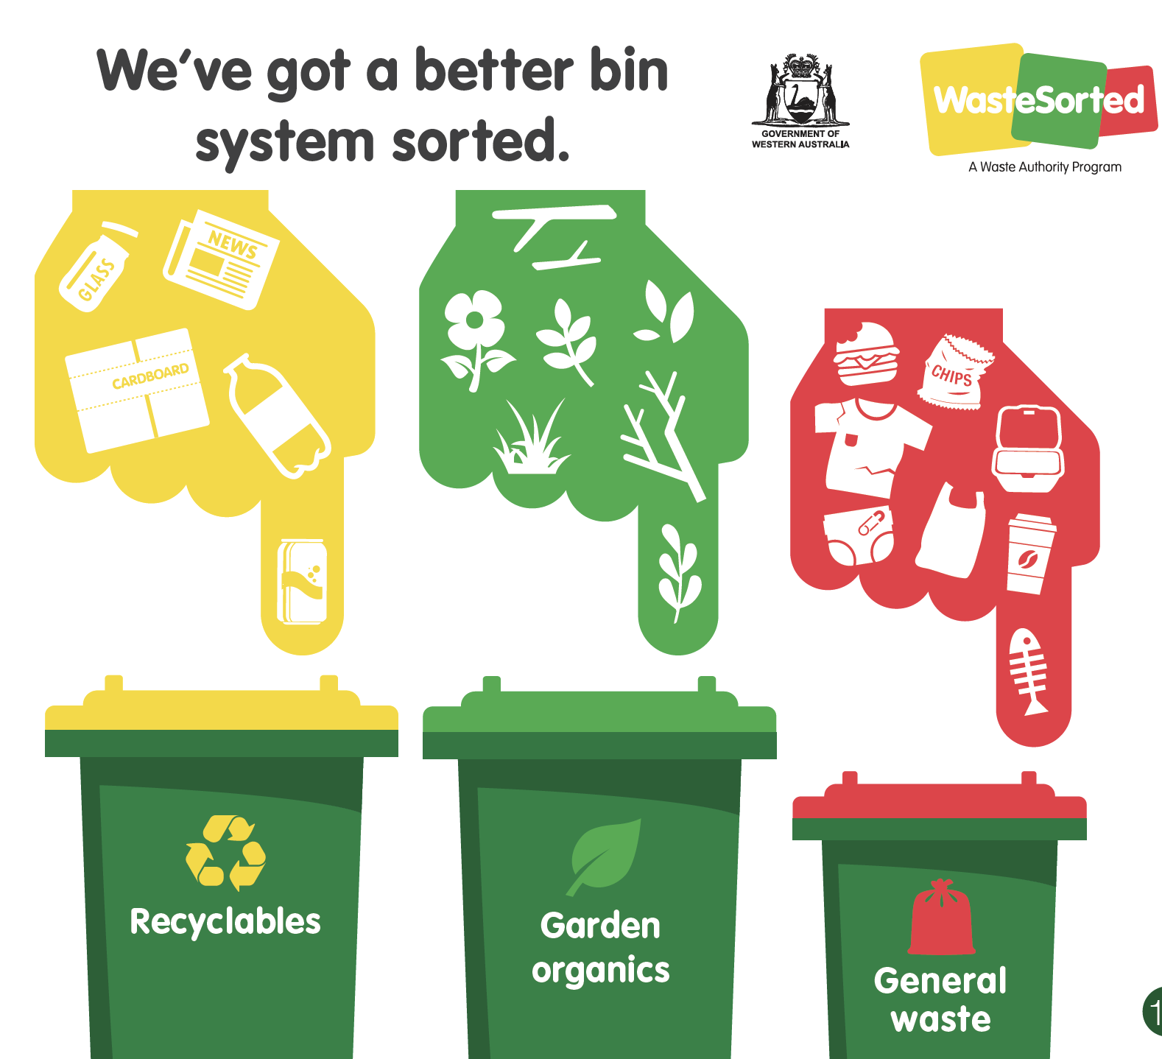

Hard Waste & Garden Organics Verge Collection
Place all verge material out by 6am on the Monday of the collection week. Do not place verge material out more than THREE days before the collection begins for your area. Separating your waste, as per picture on the next page will help us recycle.

Residential only
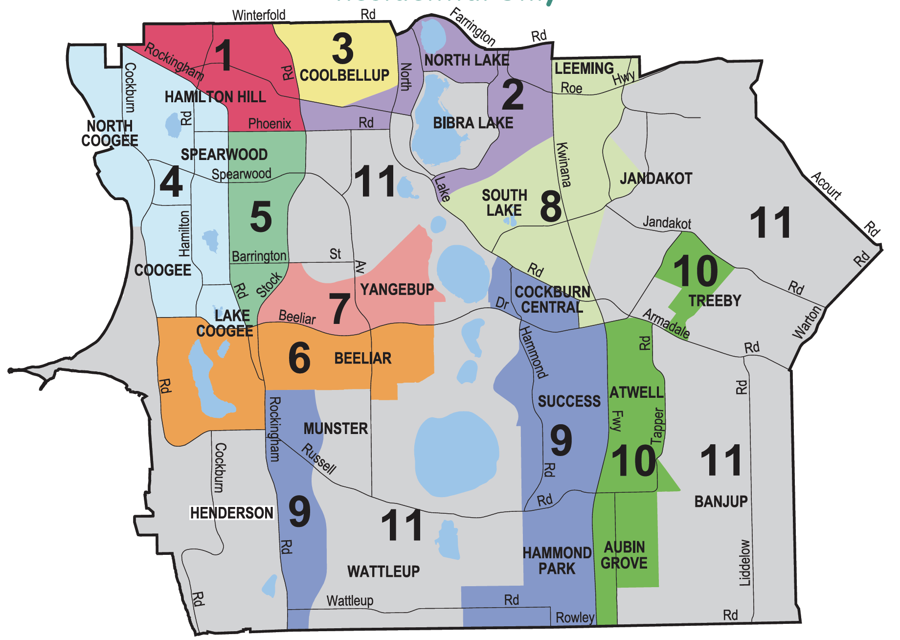
Please ensure you are aware of your correct area by number and colour.
Transcriber’s Note: Please contact City of Cockburn for more information or clarification.
The image above is a colour coded map of the City of Cockburn divided into 11 verge collection areas.
Hamilton Hill, North Coogee, Coogee, Lake Coogee, Henderson, Spearwood, Coolbellup, North Lake, Bibra Lake, South Lake, Yangebup, Munster, Beeliar, Wattleup, Cockburn Central, Success, Hammond Park, Aubin Grove, Atwell, Banjup, Treeby, Jandakot, and part of Leeming fall within the City of Cockburn and are therefore represented in the verge map.

Area 1
(Magenta pink on map)
Area 1 includes the suburb of Hamilton Hill.
Its boundaries are Winterfold Road, Stock Road, Phoenix Road, Rockingham Road, and Hampton Road.
Carrington Street and Forrest Road run through Area 1. Area 1 shares borders with Areas 2, 3, 4, 5, and 11.

Area 2
(Purple on map)
Area 2 includes the suburbs of Coolbellup, North Lake, and Bibra Lake.
Its boundaries are Farrington Road, Kwinana Freeway, Meller Road, Bibra Drive, Hope Road, Progress Drive, North Lake Road, Phoenix Road, Stock Road, and Forrest Road.
North Lake (the lake, differentiated from the suburb) is located within Area 2. Area 2 shares borders with Areas 1, 3, 8, and 11.

Area 3
(Yellow on map)
Area 3 includes the suburb of Coolbellup.
Its boundaries are Winterfold Road, North Lake Road, Forrest Road, and Stock Road.
Area 3 shares borders with Areas 1 and 2.

Area 4
(Light blue on map)
Area 4 includes the suburbs of Hamilton Hill, North Coogee, Coogee, and Spearwood.
Its boundaries are Rockingham Road, Mayor Road, Cockburn Road, and the west coast suburb boundary of North Coogee.
Manning Lake and two other lakes are located within Area 4. Cockburn Road, Spearwood Avenue, and Hamilton Road run through Area 4. Area 4 shares borders with Areas 1, 5, 6, and 11.

Area 5
(Emerald green on map)
Area 5 includes the suburbs of Spearwood and Yangebup.
Its boundaries are Phoenix Road, Stock Road, Beeliar Drive, and Rockingham Road.
Spearwood Avenue and Barrington Street run through Area 5. Area 5 shares borders with Areas 1, 4, 6, 7, and 11.

Area 6
(Orange on map)
Area 6 includes the suburbs of Coogee, Lake Coogee, and Yangebup.
Its boundaries are Mayor Road, Beeliar Drive, Senecio Lane, Fancote Avenue, Fanstone Avenue, Rockingham Road, Russell Road, and Cockburn Road.
Lake Coogee (the lake, differentiated from the suburb) and two other lakes are located within Area 6. Area 6 shares borders with Areas 4, 5, 7, 9, and 11.

Area 7
(Baby pink on map)
Area 7 includes the suburb of Yangebup.
Its boundaries are Meller Road, Pelican Ramble, Pioneer Drive, Beeliar Drive, Stock Road, and Barrington Street.
Area 7 shares borders with Areas 5, 6, and 11.

Area 8
(Pale green on map)
Area 8 includes the suburbs of South Lake, Leeming, Jandakot, and Cockburn Central.
Its boundaries include and Prinsep Road, Kwinana Freeway, Beeliar Drive, North Lake Road, Meller Road, and the northern boundary of the City of Cockburn – including Demasson Rise, Barcombe Way, Allendale Entrance and Berswick Grove.
Two lakes are located within Area 8. Kwinana Freeway, Berrigan Drive, and Karel Avenue run through Area 8. Area 8 shares borders with Areas 2, 9, and 11.

Area 9
(Azure/indigo blue on map)
Area 9 includes the suburbs of Munster, Wattleup, Cockburn Central, Success, and Hammond Park.
Area 9 is divided into two sections
The first section includes Munster and Wattleup. Its boundaries are Fanstone Avenue, Moylan Road, Dalison Avenue, Rowley Road, and Rockingham Road.
Russell Road and Wattleup Road run through this section of Area 9. This section shares borders with Areas 6 and 11.
The second section includes Cockburn Central, Success, and Hammond Park.Its boundaries are North Lake Road, Prinsep Road, Beeliar Drive, Kwinana Freeway, Rowley Road, Jacksonia Promenade, Branch Circus, and Tamara Drive.
Four small lakes are located within this section of Area 9. Hammond Road, Russell Road, and Wattleup Road run through this section, which shares borders with Areas 8, 10, and 11.

Area 10
(Lime green on map)
Area 10 includes the suburbs of Treeby, Atwell, and Aubin Grove.
Area 10 is divided into two sections.
The first section includes Treeby. Its boundaries are Jandakot Road, Armadale Road, Dollier Street, and Solomon Road. This section of Area 10 shares a border with Area 11.
The second section includes the suburbs of Atwell and Aubin Grove. Its boundaries are Armadale Road, Tapper Road, Beenyup Road, Lyon Road, Rowley Road, and Kwinana Freeway. Several small lakes are located within this section, which shares borders with Areas 9 and 11.

Area 11
(Grey on map)
Area 11 includes the suburbs of Coogee, Henderson, Munster, Yangebup, Bibra Lake, Beeliar, Wattleup, Treeby, Jandakot, Leeming, and Banjup.
Area 11 is divided into three sections.
The first section includes Coogee and Henderson. Its boundaries are Cockburn Road, Russell Road, Rockingham Road, and the west coast suburb boundaries of Coogee and Henderson.
A small lake is located in this section and Cockburn Road runs through it.
The second section includes Yangebup, Bibra Lake, Beeliar, Munster, and Wattleup. Its boundaries are North Lake Road, Tamara Drive, Beeliar Drive, Branch Circus, Jacksonia Promenade, Rowley Road, Dalison Avenue, Moylan Road, Fancote Avenue, Senecio Lane, Pioneer Drive, Pelican Ramble, Meller Road, Barrington Street, Stock Road, Phoenix Road, Progress Drive, Hope Road, and Bibra Drive.
Eight lakes, including Bibra Lake, Kogolup Lake, Thomsons Lake, and Banganup Lake are located in this section of Area 11. North Lake Road, Beeliar Drive, Russell Road, and Wattleup Road also run through this section, which shares borders with Areas 2, 5, 6, 7, 8, and 9.
The third section includes Leeming, Jandakot, Treeby, and Banjup. Its boundaries include Rowley Road and the eastern border of City of Cockburn – Acourt Road, Johnston Road and Leeming Road, Roe Highway, and Fernleaf Court.
Karel Avenue, Farrington Road, Roe Highway, Armadale Road, Ranford Road, Nicholson Road, Acourt Road, Jandakot Road, Warton Road, and Liddelow Road run through this section of Area 11. There are three small lakes in this section.

Bulk Collection Dates
Please do not present more than 2 cubic metres.
Area | Bulk Waste 1 (2023) | Bulk Garden Organics 1 (2023) | Bulk Waste 2 (2024) | Bulk Garden Organics 2 (2024)
1 | Week Starting  3 July | Week Starting  9 October | Week Starting  2 January | Week Starting  29 April
2 | Week Starting  10 July | Week Starting  1796 October | Week Starting  8 January | Week Starting  6 May
3 | Week Starting  24 July | Week Starting  23 October | Week Starting  22 January | Week Starting  13 May
4 | Week Starting  31 July | Week Starting  30 October | Week Starting  29 February | Week Starting  20 May
5 | Week Starting  7 August | Week Starting  6 November | Week Starting  12 February | Week Starting  27 May
6 | Week Starting  14 August | Week Starting  13 November | Week Starting 19 February | Week Starting  3 June
7 | Week Starting  21 August | Week Starting  20 November | Week Starting  4 March | Week Starting 10 June
8 | Week Starting  28 August | Week Starting  27 November | Week Starting  11 March | Week Starting  17 June
9 | Week Starting  11 September | Week Starting  4 December | Week Starting  25 March | Week Starting  24 June
10 | Week Starting  18 September | Week Starting  11 December | Week Starting  1 April | Week Starting  1 July
Area 11: Rural Collection will be week starting 25 September 2023 and 15 April 2024.

Important information for verge collections
Details on how to present verge waste:
- Do not place verge material out more than three days before the collection date for your area. A non-compliance notice will be issued for early “set outs”
- Ensure your verge material is presented before 6am on the Monday of your collection week. The City will not return for waste that was set out late
- Place away from walls, fences, water meters, power poles and letterboxes
- Separate white goods, steel, mattresses and e-waste from other verge collection items for recycling
- Keep checking your pile to ensure no illegal dumping has occurred (refer to following page)
- Do not place on vacant land, reserves or parklands
- Do not place on artificial turf, brick paving or driveway. Contact the City for an alternative pick up location
- Do not place under trees or over sprinklers
- Do not follow your neighbour – check your collection date
If your verge hard waste or garden organics are not compliant, we will not return to collect them.
Please do not present more than 2 cubic metres.
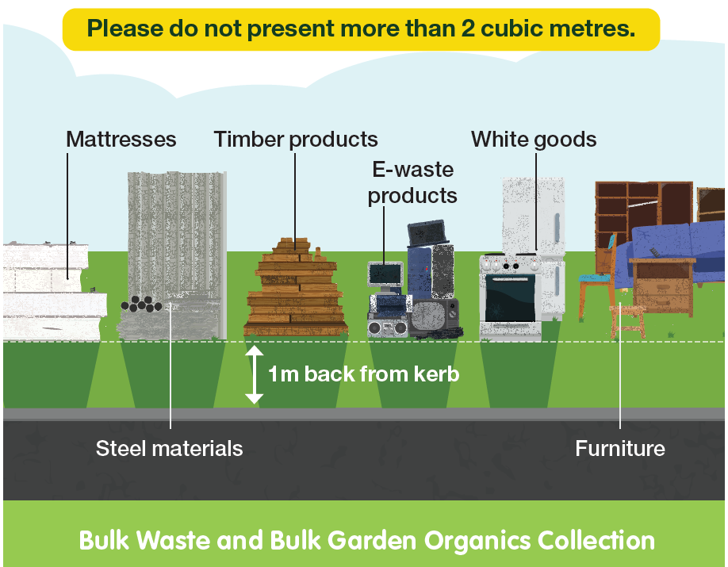
The diagram above shows bulk waste and bulk garden organics presented for verge collection:
- Mattresses, steel materials, timber products, e-waste products, white goods, and furniture are separated
- Items are 1 metre back from kerb
- Please do not present more than 2 cubic metres

Bulk Garden Organics Collections
The following items will be collected:
- Prunings up to 1.5 metres in length and 30 centimetres in diameter
Your verge garden organics are taken to the Henderson Waste Recovery Park where they are processed into mulch. The mulch is free and available to people visiting HWRP.
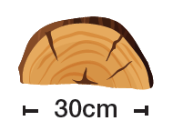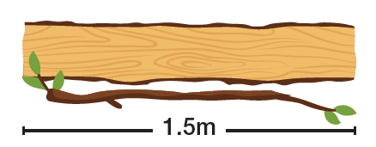
The following items will not be collected:
- Bags or boxes of leaves / grass clippings
- Loose leaves / grass clippings
- Dug out lawn
- General waste, junk or white goods
- Sand or soil materials
- Stumps or palm logs
- Weeds and root materials
- Please do not present more than 2 cubic metres
Collection as per usual on all Public Holidays, including Good Friday.
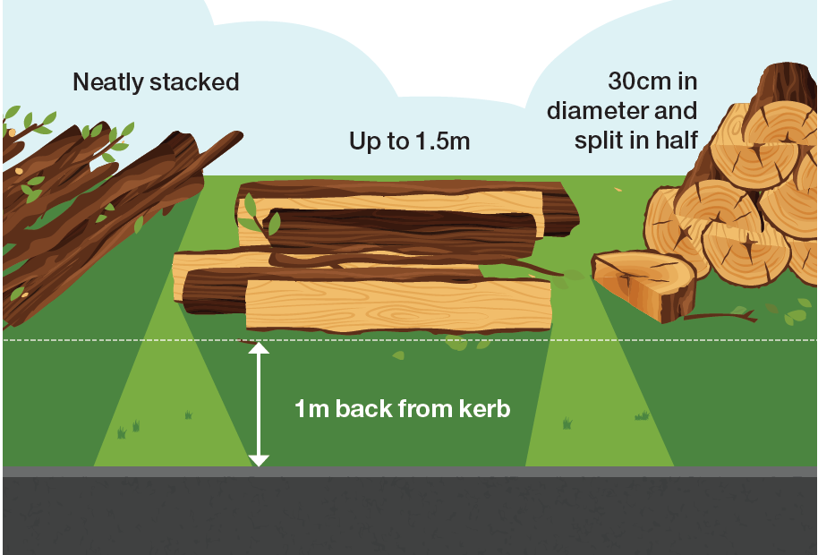
The diagram above illustrates the correct placement of bulk garden organics for verge collection:
- Neatly stacked
- Up to 1.5 metres long
- 30 centimetres in diameter and split in half
- 1 metre back from kerb

Hard Waste Verge Collections
The following items WILL be collected:
- General hard waste e.g. furniture, mattresses
Your verge hard waste is taken to the Henderson Waste Recovery Park where it is recycled or sent to landfill.
The following items WILL NOT be collected:
- Any items over 1.5m in length
- Tyres
- Asbestos, cement or glass fibre products
- Batteries, paints, chemicals, oils or other household hazardous waste
- Mirrors
- Bean bags
- Oil heaters
- Construction waste e.g. bricks, sand, cement, rubble, concrete
- Vehicle parts
- General waste, food
- Garden waste e.g. trees, dug out lawn, leaves
- Gas and air cylinders, fire extinguishers
- Plate glass, solar panels, shower screens, glass tables etc
- Pallets
- Please do not present more than 2 cubic metres
If you have difficulties presenting your waste, or are considering combining your verge waste with your neighbour, please arrange this with the City prior to the collection date.

Why waste it when you can gift it?
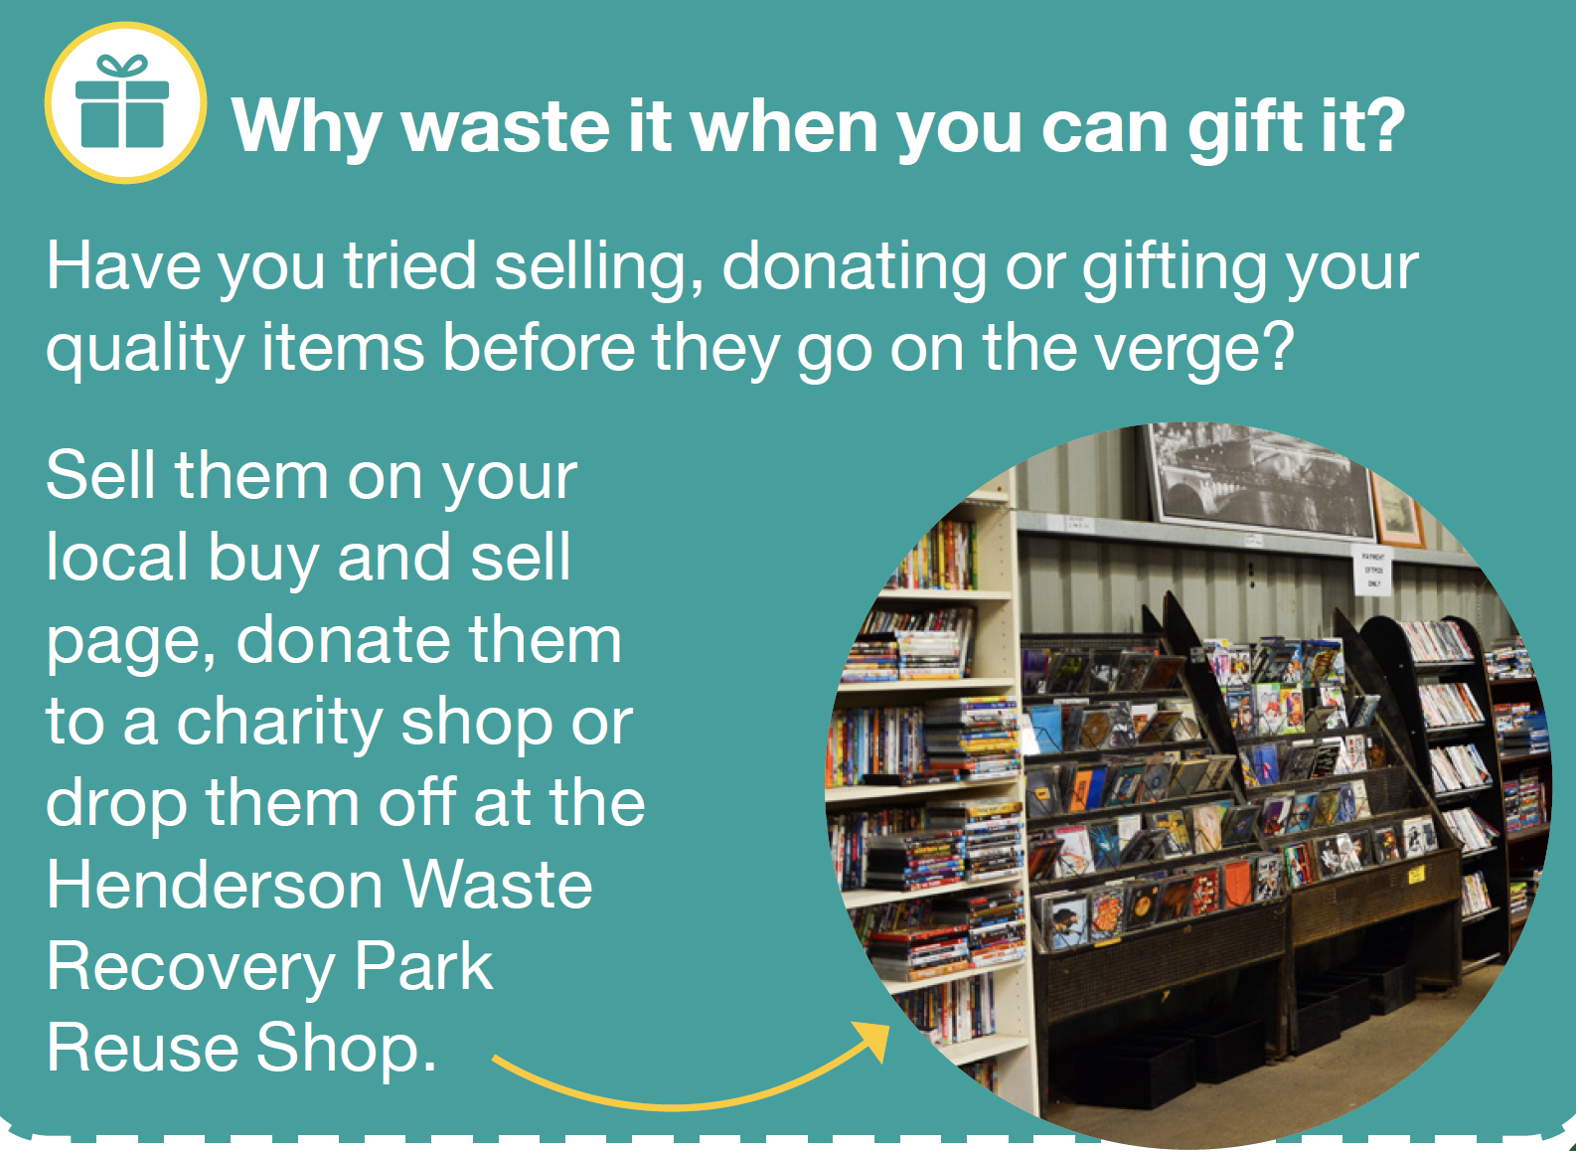
Have you tried selling, donating or gifting your quality items before they go on the verge?
Sell them on your local buy and sell page, donate them to a charity shop or drop them off at the Henderson Waste Recovery Park Reuse Shop.

Henderson Waste Recovery Park
The Henderson Waste Recovery Park is owned and managed by the City of Cockburn. It includes a landfill, a Community Drop-Off Facility, a methane power plant and a Reuse Shop.

Landfill
The City’s landfill site processes commercial waste, industrial waste, general household waste and verge waste. Valuable items that can be resold or recycled are removed from the waste stream to prevent them being sent to landfill. The site uses the latest methane recovery and leachate management technologies to limit its environmental impact.

Community Drop-Off Facility
Residents can drop off unwanted items at the Community Drop-Off Facility. These will be separated on-site and recovered if they are able to be reused or recycled.
The Community Drop-Off Facility accepts:
- Household hazardous waste e.g. paints, chemicals, oils, aerosols, batteries. Up to 20kg or litres will be accepted free, without any accompanying waste
- Construction and demolition waste (fees apply)
- Asbestos must be delivered wrapped and sealed in builder’s black plastic and separated from other waste within your trailer. It should be wrapped in parcels that are easily lifted by hand (fees apply)
- Mattresses four mattresses per customer can be accepted (fees apply). Commercial quantities of mattresses can be recycled at the Eastern Metropolitan Council, call (08) 9274 7807
- General waste including wood, metal, cardboard, plastic etc
- E-Waste (free if eligible)
- Green waste (fees apply)
- Cardboard (free if clean)
- Polystyrene (free if clean).
 Community Recycling Hubs
You can drop off small quantities of dry-cell batteries, light globes, mobile phones and printer toner cartridges at Cockburn ARC , the Wetlands Centre Cockburn, Cockburn Gateways Shopping Centre and Cockburn Libraries in Spearwood, Coolbellup and Success.
You can also drop off aerosol cans to the front counter at the Administration Building (9 Coleville Crescent, Spearwood), Seniors Centre, Coolbellup Hub, the Wetlands Centre Cockburn, Aubin Grove Sport and Community Facility, Cockburn ARC and the Operations Centre (52 Wellard Street, Bibra Lake).

Trailer Passes
All City of Cockburn households receive six trailer passes per year to allow them to bring their waste to Henderson Waste Recovery Park. Trailer passes are non-transferable and cannot be sold. Use of trailer passes is monitored by the City and any attempt to sell, swap or trade passes on social media platforms, Gumtree or any other means will result in cancellation of all six trailer passes.
Please note: Trailer passes can also be used to drop off green waste to the Regional Resource Recovery Centre:
350 Bannister Road Canning Vale | 08 9256 9555 Open 7 days, 8am−4pm.

Compost
Mulch used as weed suppression is no longer available at Henderson Waste Recovery Park. Instead, free compost for soil enrichment, moisture retention and the promotion of plant growth is available.
Bring along a trailer or utility vehicle and load the compost yourself. Ensure that you wear gloves, a dust mask and enclosed shoes. Staff are not able to help with loading compost into vehicles.
$4 bags of compost can be purchased from the Reuse Shop when open and when the product is available.

Reuse Shop
The Reuse Shop sells many items that have been recovered from the waste stream rather than going to landfill. Pick up a bargain at the Reuse Shop Friday – Sunday 8am to 4pm. Not open public holidays.
920 Rockingham Road, Wattleup | 08 9411 3444 Community Drop-Off Facility is open 7 days, 8am−4.30pm except Christmas Day, New Year’s Day and Good Friday.
Find out how the City can help you reduce waste to landfill and live more sustainably through the City’s environmental rebates. From home compost systems to cloth nappies and sanitary product subsidies, find out more at City of Cockburn website: www.cockburn.wa.gov.au
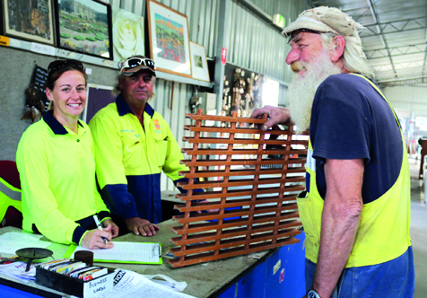
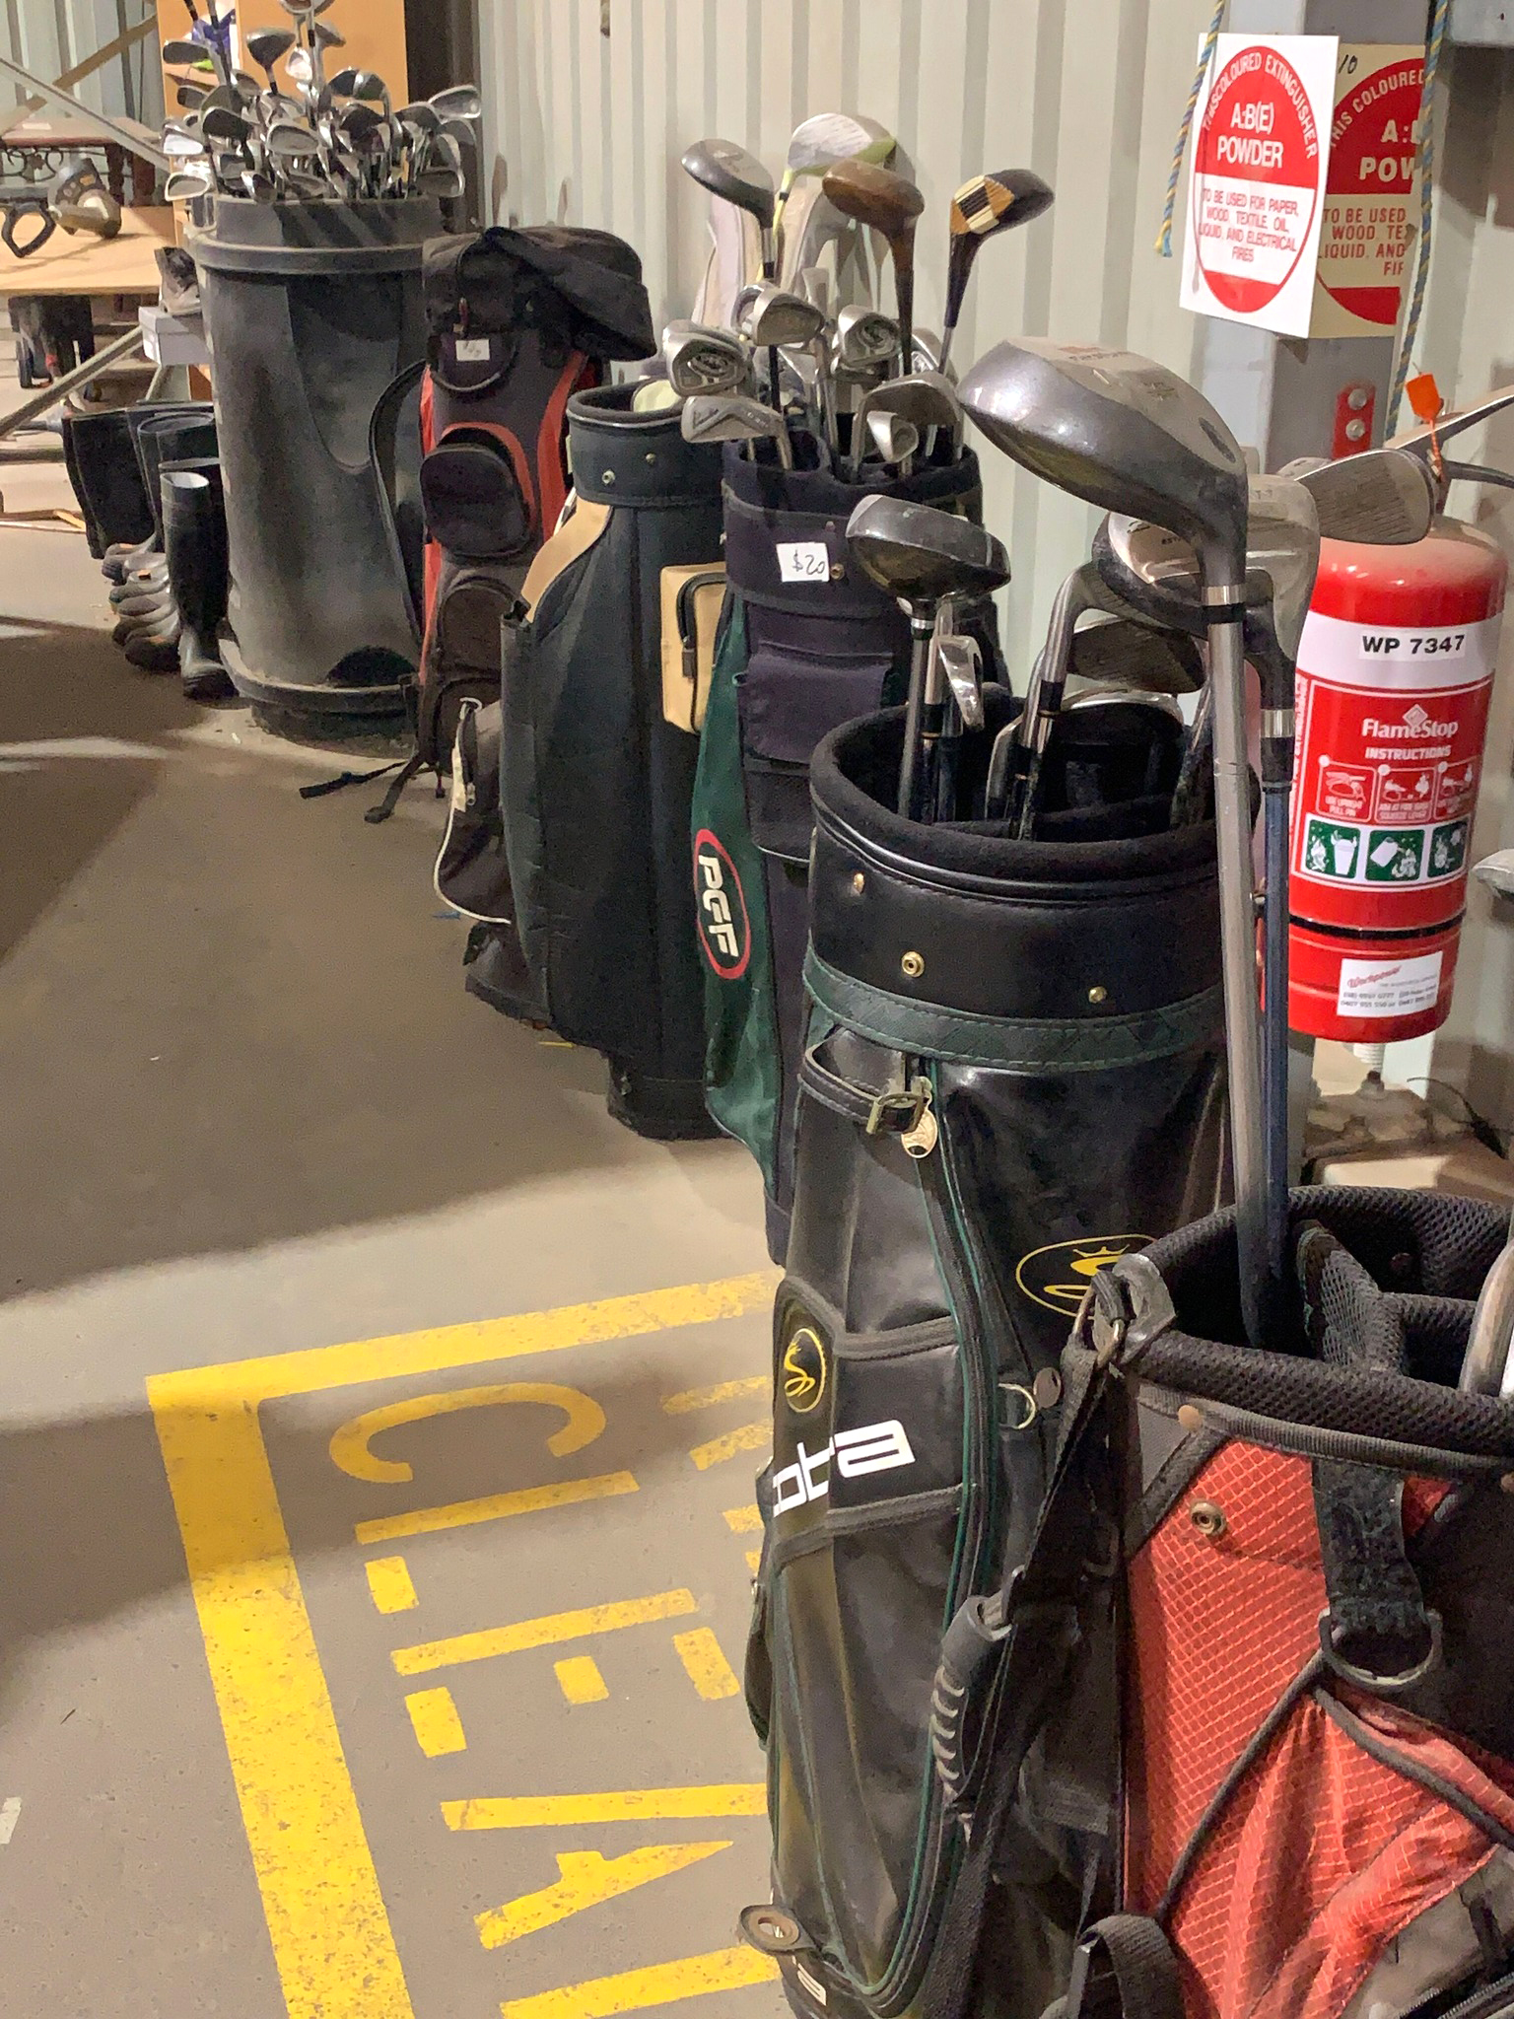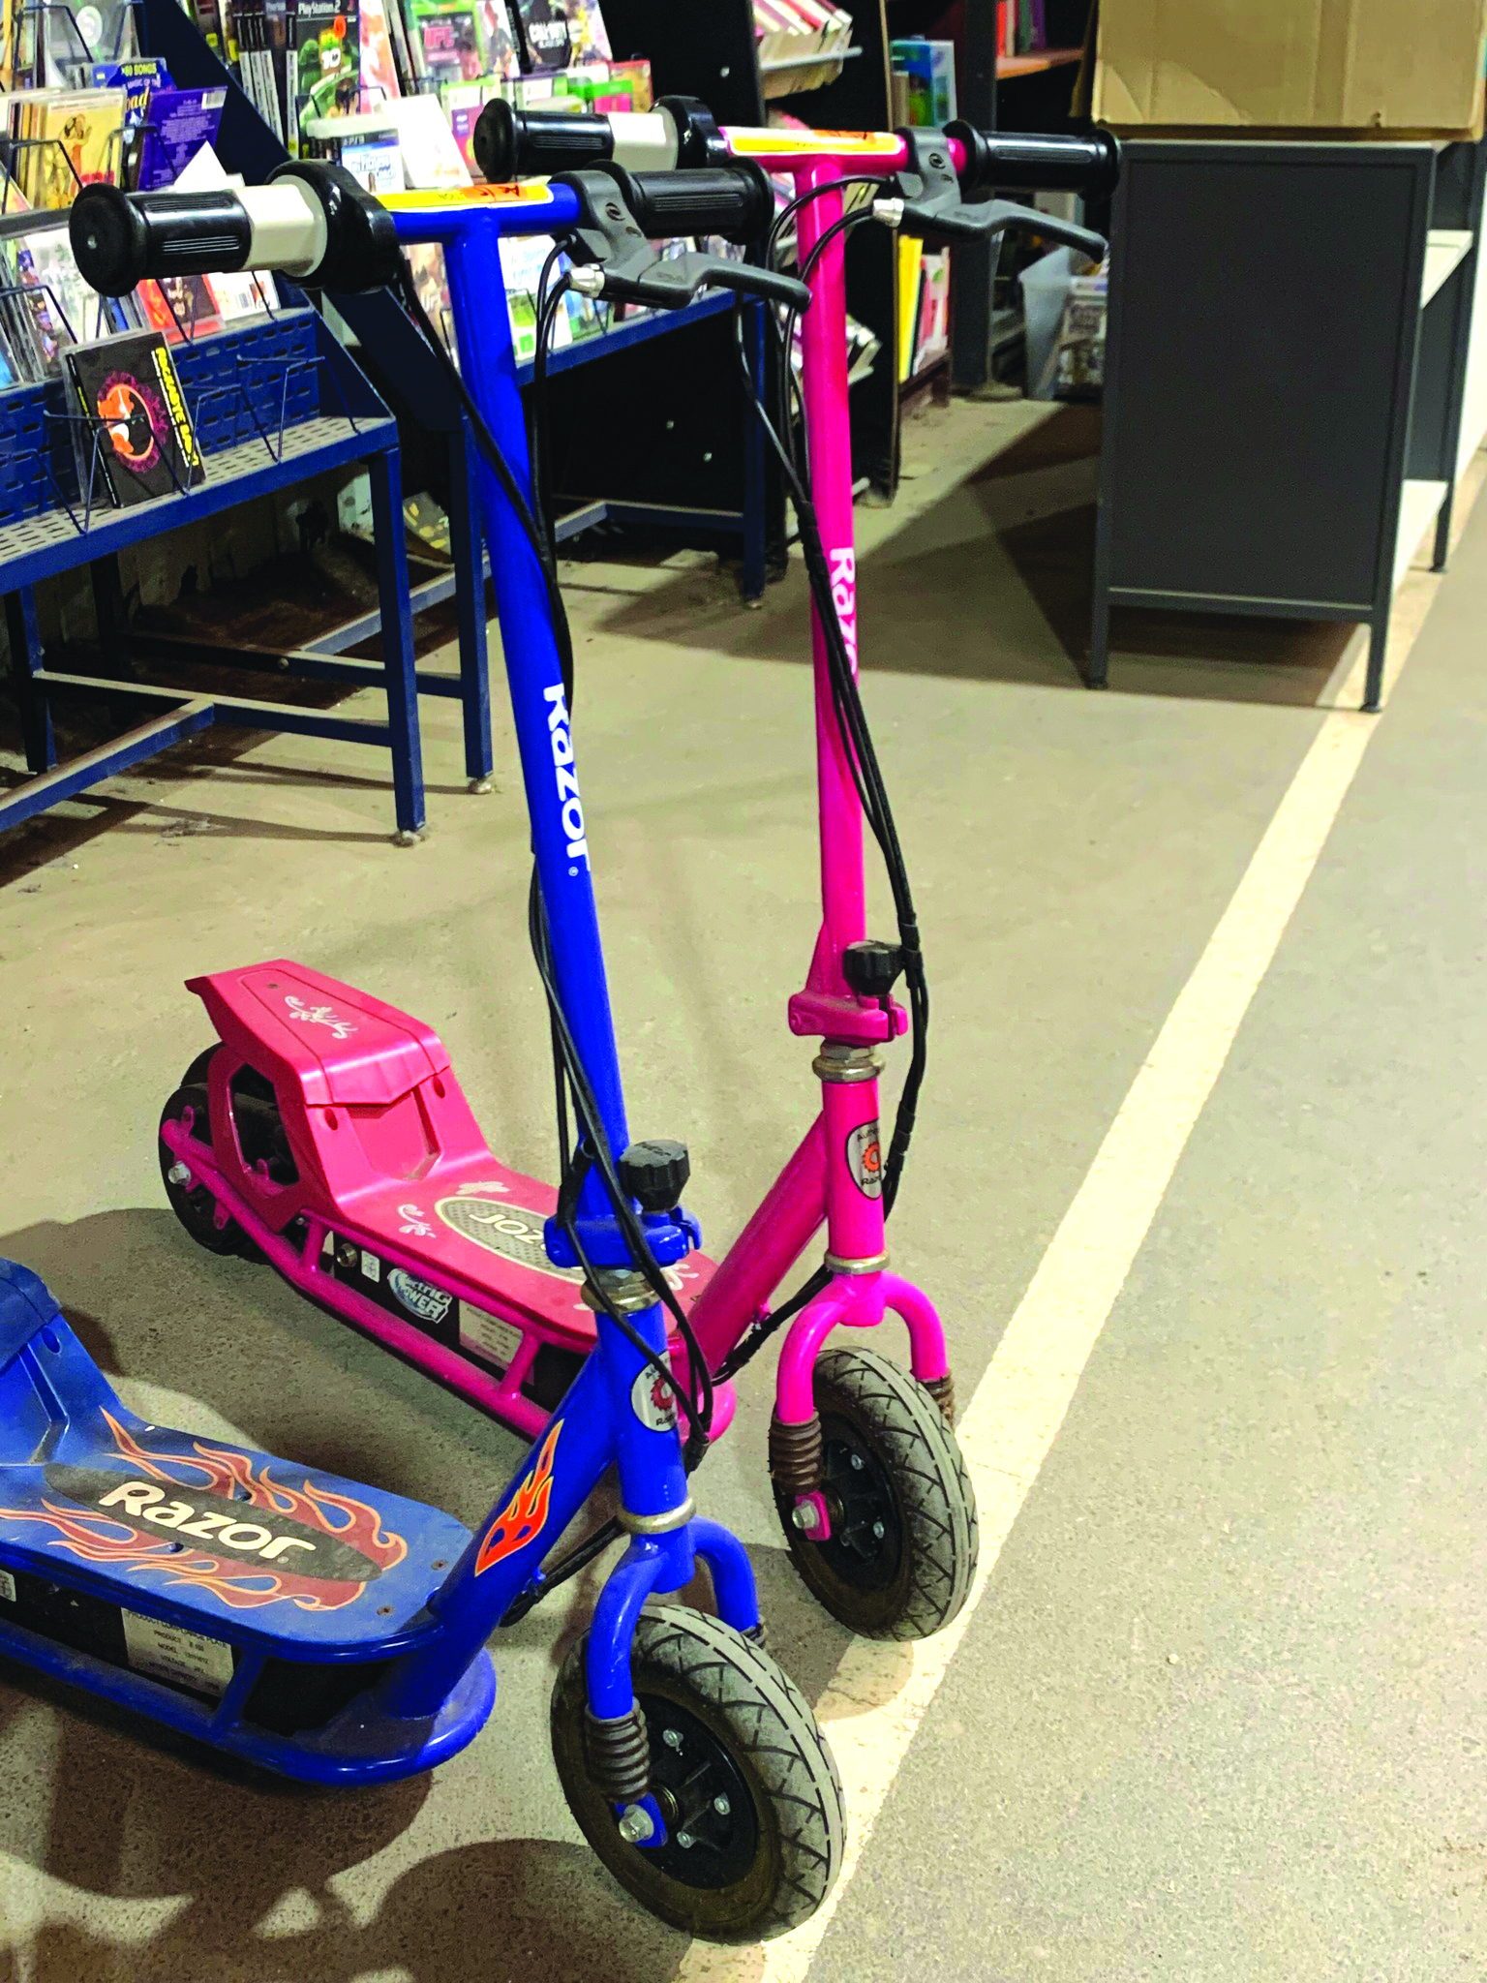

More Information
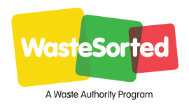
When you no longer need this calendar, please place it in the yellow-top recycling bin.
When you no longer need this calendar, please place it in the yellow-top recycling bin.
The calendar is available on the City of Cockburn’s website in PDF and in Croatian, Chinese, Tagalog, Portuguese and Italian. If you require further information please contact Customer Service on 08 9411 3444.
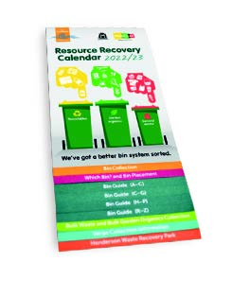
Hard copies of this calendar are available at City libraries and the Cockburn Administration Centre.

Contact
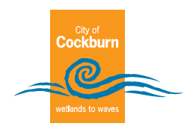
City of Cockburn
Whadjuk Boodjar
9 Coleville Cresent, Spearwood WA 6163
Office hours 8.30am–4.30pm
Monday – Friday (closed Public Holidays)
Phone: 08 9411 3444
Email: customer@cockburn.wa.gov.au

City of Cockburn website: www.cockburn.wa.gov.au
 This information is available in alternative formats upon request.

