Tender Title: |  | RFT 02/2023  Construction Services (Manufacture & Installation) Maraboo & Othello Bridge Anti Climb Structure
Request ID: |  | 46683
Tender Description: |  | The City of Cockburn (the Principal) is seeking an experienced Construction Contractor for works associated with the Steel & Aluminium barrier located at Maraboo & Othello bridges, Maraboo Loop & Othello quays Port Coogee, WA.
Advert Approval: |  | Decision to Advertise: Chief Operations Officer  Decision Date: Tuesday, 2 May 2023
Closing Date and Time: |  | 2:00PM (AWST) Wednesday, 31 May 2023
Opening Date and Time: |  | 2:00PM (AWST) Wednesday, 31 May 2023
 | Tenderer’s Name:
1 | Sarich Autos t/a Densford Civil Pty Ltd
2
3
4
5
6
7
8
9
10

Advertisement
Method 1: City of Cockburn | Method 2: Yammer
Method 3:  The Western Australian,  Saturday, 6th May 2023 | Tender Awarded by:
Copy of Statewide Notice:  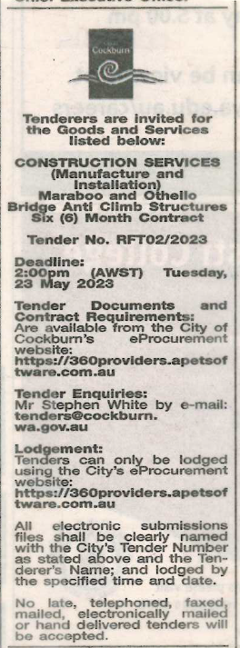 | Chief Operations Officer  Tuesday, 18 July 2023  A/ Chief Financial Officer  Thursday, 13 July 2023
 | Date of Council Meeting:
 | Not applicable
Name of Successful Tenderer(s): | Densford Civil Pty Ltd
Amount of Successful Tender(s): (ex GST) | $525,924

