Tender Title: |  | RFT 19/2022  Garden & Green Waste Composting or Processing
Request ID: |  | 46601
Tender Description: |  | The City of Cockburn (the Principal) is seeking a suitably experienced and equipped Contractor to convert the City’s raw garden waste from the gardens organics bin to compost, compliant with AS 4454-2012 Composts, Soil Conditioners and Mulches.
Advert Approval: |  | Decision to Advertise: Chief Operations Officer  Decision Date: Friday, 25 November 2022
Closing Date and Time: |  | 2:00PM (AWST) Wednesday, 11 January 2023
Opening Date and Time: |  | 2:00PM (AWST) Wednesday, 11 January 2023
 | Tenderer’s Name:
1 | JD Organics t/a Go Organics
2 | Resource Recovery Group
3 | Western Tree Recyclers
4
5
6
7
8
9
10

Advertisement
Method 1: City of Cockburn | Method 2: Yammer
Method 3:  The Western Australian,  Wednesday 30th of November 2022 | Tender Awarded by:
Copy of Statewide Notice:  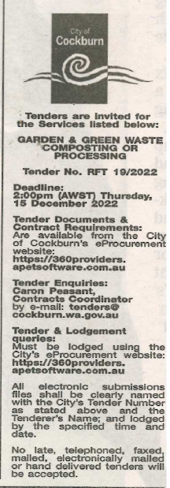 | OCM  Thursday, 9 March 2023
 | Date of Council Meeting:
Thursday, 9 March 2023
Minutes: 0047
Item No: 14.2.1
Name of Successful Tenderer(s): | JD Organics Pty Ltd t/a  Go Organics
Amount of Successful Tender(s): (ex GST) | $2,941,925

